**CNG KIT CYLINDER & PARTS MANGEMENT SYSTEM**

**OF**

**ENERGY ZONE**

**GROUP MEMBERS**

**MUHAMMAD UNAIS-17B-017-SE-SEM 1V SE-A**

**SHOAIB AHMED-17B-033-SE-SEM IV SE-A**

**HASSAN AHMED-17B-049-SE.SE A-SEM IV SE-A**

**ALI AKBAR-16B-056-SE-SEM IV SE-A**

**MAHAM UZAIR-16B-014-SE-SEM IV SE-A**

**COURSE INSTRUCTOR**

**INSTRUCTOR NAME: USMAN WAHEED**

**TOPIC**

**BLACKBOX TESTING**

**USMAN INSTITUTE OF TECNOLOGY**

Contents

Add Customer Interface 8

List of 3 valid values 9

Control Testing 9

1. Textbox (Alphanumeric, Numeric, Alphabetic, Formatted) 9

Contributors 9

Step Based Guidance: 15

2. Dropdown List Box 17

Contributors 17

Purpose 17

3. Command Buttons 20

Contributors 20

Purpose 20

Category: 20

Test cases (step based): 21

Guidelines 22

**REFERENCES:** 24

Requirements: 25

STRATEGY 25

Interface Testing 26

**1.** **Aesthetic Conditions:** 26

Contributors 26

Contributors 29

**3.** **Navigation Condition** 33

Contributors 33

**4.** **USABILITY TESTING:** 36

Contributors 36

Contributors 40

**6.** **Feedback** 43

Contributors 43

**7.** **Modes** 46

Contributors 46

**8.** **General Condition** 49

Contributors 49

**REFERENCES** 54

**Requirements:** 56

**STRATEGY:** 56

Develop a Driver (for single interface) 57

**PROPOSED INTERFACE** 57

FIGURE :1 57

Add Purchase and Service Interface 58

List of 3 valid values 58

Control Testing 59

1. Textbox (Alphanumeric, Numeric, Alphabetic, Formatted) 59

Contributors 59

2. Dropdown List Box 62

Contributors 62

Purpose 62

Test cases (input based): 62

3. Command Buttons 64

Contributors 64

Purpose 64

Category: 65

Test cases (input based): 65

None 65

Test cases (step based): 65

Guidelines 67

**REFERENCES** 68

**Requirements:** 69

**STRATEGY:** 69

Interface Testing 70

1. Aesthetic Conditions: 70

Contributors 70

**2.** **Validation Conditions** 73

Contributors 73

**3.** **Navigation Condition** 77

Contributors 77

**4.** **Usability Conditions** 80

Contributors 80

**5.** **Data Integrity Conditions** 84

Contributors 84

**6.** **Feedback** 87

Contributors 87

**7.** **Modes** 90

Contributors 90

**8.General Condition** 93

Contributors 93

**REFERENCES** 99

**Requirements:** 101

**STRATEGY** 101

Develop a Driver (for transactional interface) 102

**PROPOSED INTERFACE** 102

FIGURE :1 102

FIGURE :2 103

Vendor Order Interface 104

List of 3 valid values 108

Control Testing 109

1. Textbox (Read-only, Alphanumeric, Numeric, Alphabetic) 109

Contributors 109

Purpose 109

Category: 110

Test case (input Based) 110

Test case (input Based) 110

Test cases (step based) 113

Guidelines 115

2. Dropdown-Box List 117

Contributors 117

Purpose 117

Category 117

Test Cases (Input based) 118

Test Cases (Steps Based) 119

Guidelines 121

3. Button 122

Contributors 122

Purpose 122

Category 123

Test Cases (Steps Based) 123

Guidelines 126

4. Radio Button 127

Contributors 127

Purpose 127

Category 127

Test Cases (Input based) 127

Test Cases (Steps Based) 128

Guidelines 128

5. Image 129

Contributors 129

Purpose 129

Category 129

Test Cases (Input based) 129

Test Cases (Steps Based) 130

Guidelines 131

6. Table or Grid 132

Contributors 132

Purpose 132

Category 132

Test Cases (Steps Based) 132

Guidelines 133

References 134

REQUIREMENTS: 135

STRATEGY: 135

Interface Testing 136

1. Aesthetic Conditions: 136

Contributors 136

2. **Validation Conditions** 139

Contributors 139

3. **Navigation Condition** 144

Contributors 144

4. **Usability Conditions** 147

Contributors 147

5. **Data Integrity Conditions** 154

Contributors 154

6. **Feedback** 157

Contributors 157

**8.** **Modes** 161

Contributors 161

**8. General Condition** 164

Contributors 164

**REFERENCES** 171

REQUIREMENTS: 173

**STRATEGY:** 173

Develop a Driver (for transactional interface) 174

**PROPOSED INTERFACE** 174

FIGURE :1 174

FIGURE :2 175

Application Testing 176

Contributors 176

**1.** **Screen Containers** 176

• Does application have navigation container? 176

• Does application have view container? 177

**2.** **Element selection** 178

1. Does application have text box? 178

2. Command button 179

3. Does application have radio button? 179

4. Does application have dropdown list? 180

5. Does application have table or Grid? 180

6. Does application have Image inserting? 181

**3.** **Element layout** 182

**4.** **Color theme** 183

**5.** **Alignment of text** 184

**6.** **Element placement Style** 185

**7.** **Navigation Style** 186

• App navigation 186

**8.** **Feedback Style** 187

**9.** **Support Style** 188

**10.** **Mouse cursor style** 189

**11.** **Interface Style** 190

**REQIREMENTS** 192

**STRATEGY** 192

# Add Customer Interface

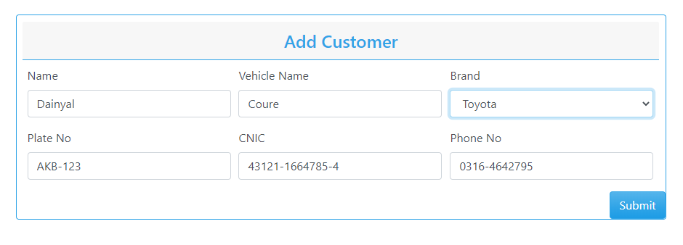

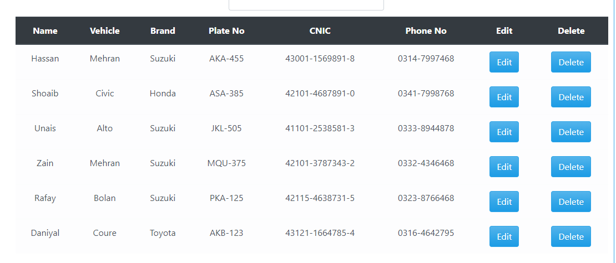

### List of 3 valid values

|  |  |  |  |
| --- | --- | --- | --- |
| **Control name** | **Valid value 1** | **Valid value 2** | **Valid value 3** |
| Textbox (Alphabetic) | Hassan, Platz | HASSAN, PLATZ | Hassan, platz |
| Textbox (Formatted, Numeric) | 0332-3214569, 42115-4638731-5 | 0344-9852146, 42101-3787343-2, | 0310-3547896, 41101-2538581-3 |
| Textbox (Formatted, Alphanumeric) | AKA-455 | JKL-505 | MQU-375 |
| Dropdown list | - | - | - |
| Command button | - | - | - |

# Control Testing

### Textbox (Alphanumeric, Numeric, Alphabetic, Formatted)

### Contributors

SHOAIB AHMED, 17b-033-se@students.uit.edu, Usman Institute of Technology.

**Purpose**

Textboxes are text fields that enable the user to enter some text. The user can also display or edit a text or numeric value. Its purpose is to take input from the user. It is an input control unit. A text box is a rectangle of any size with a border that separates the text box from the rest of the interface. By clicking on textbox, a cursor is displayed so that you can begin typing. It is common for the [mouse](https://en.wikipedia.org/wiki/Computer_mouse) [cursor](https://en.wikipedia.org/wiki/Cursor_(computers)) to change its shape when it hovers over a text box. We can enter any type of text, it can be numeric, alphanumeric or alphabetic. Text box is used to enter and retrieve data to backend database, or can contain in some case default values.

**Example**

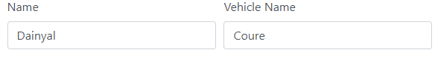

Figure 1: Textbox for alphabetic values

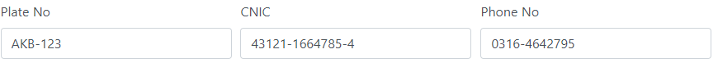

Figure 2: Textbox for alphanumeric formatted values



Figure 3: Textbox for numeric formatted values



Figure 4: Textbox for numeric formatted values

In Figure 1: **Daniyal and Coure** is an alphabetic text written in the textbox used for simple alphabetical data.

In Figure 2: **AKB-123** is an alphanumeric formatted CAR PLATE NUMBER text written in the textbox used for alphanumeric formatted data.

In Figure 3: **43121-1664785-4** is a numeric formatted CNIC text written in the textbox used for numeric formatted data.

In Figure 4: **0316-4642795** is a numeric formatted PHONE NO text written in the textbox used for numeric formatted data.

**Category:**

Input control

**Test case (input Based)**

* Does it only accept the alphabet values?

|  |  |  |  |
| --- | --- | --- | --- |
| Test case Name | Input | Output | Valid /Invalid |
| Alphabetic Data | Hafsa Akhter | Correct input | Valid |
| Hafsa4565 | Incorrect input | Invalid |

* Does it accept the numeric content?

|  |  |  |  |
| --- | --- | --- | --- |
| Test case Name | Input | Output | Valid /Invalid |
| Numeric data | Hafsa | Correct input | Valid |
| 35561 | Incorrect input | Invalid |

* Does it accept the symbols?

|  |  |  |  |
| --- | --- | --- | --- |
| Test case Name | Input | Output | Valid /Invalid |
| Symbolic Data | Hafsa | Correct input | Valid |
| ^hafsa | Incorrect input | Invalid |

* Does the text field accepts uppercase alphabets?

|  |  |  |  |
| --- | --- | --- | --- |
| Test case Name | Input | Output | Valid /Invalid |
| Uppercase alphabets | HAFSA | Correct input | Valid |
| HAFS67 | Incorrect input | Invalid |

* Does the text field accepts lowercase alphabets?

|  |  |  |  |
| --- | --- | --- | --- |
| Test case Name | Input | Output | Valid /Invalid |
| Lowercase alphabets | hafsa | Correct input | Valid |
| Hafsa538 | Incorrect input | Invalid |

* Does the text field accepts mix of upper and lowercase alphabets?

|  |  |  |  |
| --- | --- | --- | --- |
| Test case Name | Input | Output | Valid /Invalid |
| Upper and lowercase alphabets | HaFsA | Correct input | Valid |
| HaFsA35561 | Incorrect input | Invalid |

* Does the text field allows copy paste?

|  |  |  |  |
| --- | --- | --- | --- |
| Test case Name | Input | Output | Valid /Invalid |
| Copy paste | HaFsA | Copied Text | Valid |
| HaFsA35561 | Original Text | Invalid |

* Does the text field allow drag and drop of text content?

Some of the text Fields do allow drag and drop of text contents and some don’t so the accepting condition is shown.

|  |  |  |  |  |
| --- | --- | --- | --- | --- |
| Test case Name | Input | Conditions | Output | Valid /Invalid |
| Alphanumeric Data | HaFsA | Drag And Drop Text | Function Working | Valid |
| HaFsA35561 | Original Text | Function working | Valid |

* Does the text field allows spaces?

|  |  |  |  |
| --- | --- | --- | --- |
| Test case Name | Input | Output | Valid /Invalid |
| Allows spaces | HafsaAkhtar | Correct input | Valid |
| Hafsa Akhtar | Correct Input | Valid |

* Does the textbox field is editable after retrieving data from Database?

|  |  |  |  |
| --- | --- | --- | --- |
| Test case Name | Input | Output | Valid /Invalid |
| Retrieving data from Database | Data retrieved from database | Data Showed | Valid |
| Hassan123 or Hassan | Data is editable | Valid |

* Does its limit is 20 character for name?

|  |  |  |  |
| --- | --- | --- | --- |
| Test case Name | Input | Output | Valid /Invalid |
| Alphabetic Data | Mustansar Hussain tarrar | Textbox filled green display | Valid |
| Mustansar Hussain tarrar ahmedia | Please enter less than 21 character | Invalid |

* Does its limit is 12 character for vehicle name?

|  |  |  |  |
| --- | --- | --- | --- |
| Test case Name | Input | Output | Valid /Invalid |
| Alphabetic Data | Corolla | Textbox filled green display | Valid |
| Corolla city platz | Please enter less than 13 character | Invalid |

* Does its min limit is 3 character for name?

|  |  |  |  |
| --- | --- | --- | --- |
| Test case Name | Input | Output | Valid /Invalid |
| Alphabetic Data | Ali | Textbox filled green display | Valid |
| Al | Enter 3 character | Invalid |

* Does its limit is 2 character for vehicle name?

|  |  |  |  |
| --- | --- | --- | --- |
| Test case Name | Input | Output | Valid /Invalid |
| Alphabetic Data | AD | Textbox filled green display | Valid |
| A | Enter 2 character | Invalid |

* Does the “Formatted Textbox” which should have proper format predefined and accepting the same number characters in the same format for ex: CNIC number should accept XXXX-XXXXXXXX-X in this format and - - characters should be displayed in TextBox before entering anything in CNIC field?

|  |  |  |  |
| --- | --- | --- | --- |
| Test case Name | Input | Output | Valid /Invalid |
| Formatting | 4215-25461252-8 | Textbox filled green display | Valid |
| Abcd-456-sadhbd-hel | CNIC number should accept XXXX-XXXXXXXX-X format | Invalid |

* Does the “Formatted Textbox” which should have proper format predefined and accepting the same number characters in the same format for ex: CNIC number should not accept all zero number in this in CNIC field?

|  |  |  |  |
| --- | --- | --- | --- |
| Test case Name | Input | Output | Valid /Invalid |
| Formatting | 4215-25461252-8 | Textbox filled green display | Valid |
| 0000-00000000-0 | CNIC number should not accept all zero. | Invalid |

* Does the “Formatted TextBox” which should have proper format predefined and accepting the same number characters in the same format for ex: phone number should accept XXXX-XXXXXXX in this format and - - characters should be displayed in Textbox before entering anything in phone number. field?

|  |  |  |  |
| --- | --- | --- | --- |
| Test case Name | Input | Output | Valid /Invalid |
| Formatting | 0332-5647891 | Textbox filled green display | Valid |
| 03-32564789-1 | Phone number should accept XXXX-XXXXXXX format | Invalid |

* Does the “Formatted Textbox” which should have proper format predefined and accepting the same number characters in the same format for ex: phone number should not accept all zero number in this in phone number field?

|  |  |  |  |
| --- | --- | --- | --- |
| Test case Name | Input | Output | Valid /Invalid |
| Formatting | 0312-1254789 | Textbox filled green display | Valid |
| 0000-0000000 | Phone number should not accept all zero number | Invalid |

* Does the “Formatted Textbox” which should have proper format predefined and accepting the same number characters in the same format for ex: phone number should 03 format number in this in phone number field?

|  |  |  |  |
| --- | --- | --- | --- |
| Test case Name | Input | Output | Valid /Invalid |
| Formatting | 0312-1254789 | Textbox filled green display | Valid |
| 0212-1254789 | Phone number should 03 format number | Invalid |

* Does the “Formatted Textbox” which should have proper format predefined and accepting the same number characters in the same format for ex: phone number should contain 0300 to 0349 format number in this in phone number field?

|  |  |  |  |
| --- | --- | --- | --- |
| Test case Name | Input | Output | Valid /Invalid |
| Validation of first 4 numbers | 0349-1254789 | Textbox filled green display | Valid |
| 0360-1254789 | Phone number should contain 0300 to 0349 | Invalid |

* Does the “Formatted TextBox” which should have proper format predefined and accepting the same number characters in the same format for ex: car plate no should accept XXX-XXX in this format and - - characters should be displayed in Textbox before entering anything in car plate no field?

|  |  |  |  |
| --- | --- | --- | --- |
| Test case Name | Input | Output | Valid /Invalid |
| Formatting | AKB-121 | Textbox filled green display | Valid |
| AK-B121 | Car plate no should accept XXX-XXX format | Invalid |

* Does the “Formatted TextBox” which should have proper format predefined and accepting the same number characters in the same format for ex: car plate no should not accept numbers in first 3 alphabet and alphabet in last three number in car plate no field?

|  |  |  |  |
| --- | --- | --- | --- |
| Test case Name | Input | Output | Valid /Invalid |
| Formatting | AKB-121 | Textbox filled green display | Valid |
| AK1-B21 | Car plate no should not accept numbers in first 3 alphabet and alphabet in last three number | Invalid |

* Does the “Formatted Textbox” which should have proper format predefined and accepting the same number characters in the same format for ex: car plate no should accept all zero in car plate no field?

|  |  |  |  |
| --- | --- | --- | --- |
| Test case Name | Input | Output | Valid /Invalid |
| Zero value | AKB-121 | Textbox filled green display | Valid |
| 000-000 | Car plate no should accept all zero | Invalid |

### Step Based Guidance:

* Does Moving the Mouse Cursor over all Enterable Text Boxes. Do Cursor change from arrow to Insert Bar.

**Guide lines**

* Does the blinking cursor appear while typing the content?
* Does the characters that are type in the textbox are in the right format?
* Does it show RED asterisk for mandatory fields? (as per requirements)
* Does the correct “Text” associate with Textbox?
* Does it have the correct formatted pattern for the “Formatted Textbox”?
* Does the cursor change from arrow to Insert Bar when moved over all textboxes?
* Does the formatted textbox not accept less than allocated characters?
* Does the textbox stop accepting when reached its allocated characters by overflowing the in textbox?

### Dropdown List Box

### Contributors

SHOAIB AHMED, 17b-033-se@students.uit.edu, Usman Institute of Technology.

### Purpose

The purpose of drop-down list box, users make a choice among a list of mutually exclusive values. Users can choose one and only one option. With a standard drop-down list, users are limited to choices in the list.

**Example**

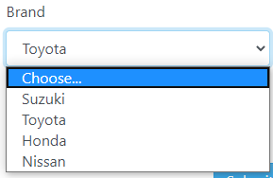

Figure 1 Dropdown list Box

In Figure 1: we have dropdown list box with several option in which we can any option from the given list, such as we have selected car brand.

**Category: Selective Control**

**Test cases (step based)**

* Do click on the arrow of the control and check if list should be displayed?

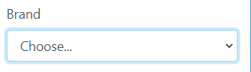

Figure 2 Car Brand Drop Down List Box

Select any one option from the list

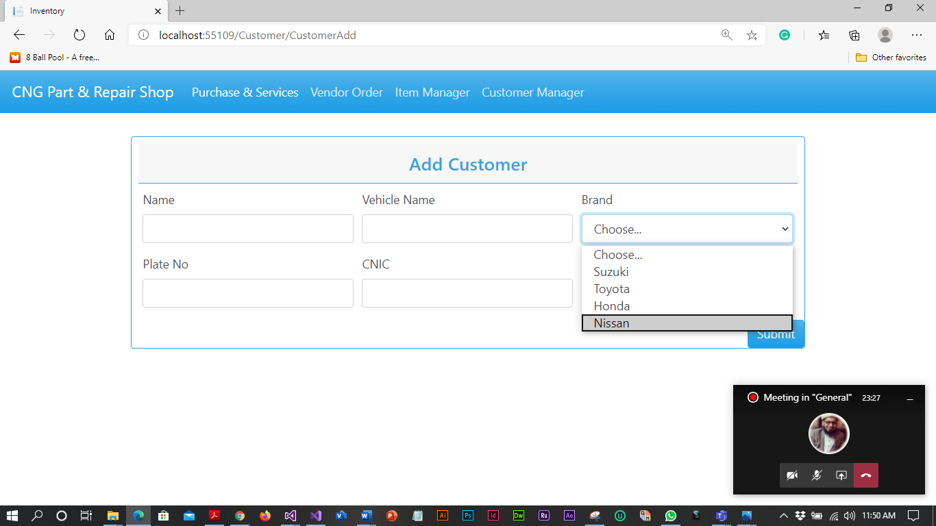

Figure 3 Car Brand Drop Down List

Car brand would be selected according to the selected method



Figure 3 Car Brand Selected Drop Down List

**Guide lines**

* Do check for appropriate sign displayed (as arrow) over control.
* Do check for default value that should be displayed or it should be BLANK.
* Do check if list contains number of values then “Scroll” option should display and it should be working.
* Do check for alignment of list is associated with control.
* Do check for “TEXT” identifier displayed with the control.
* Do check after clicking on arrow image should display as clicked.
* Does all the dropdowns on this screen sorted correctly? Alphabetic sorting is the default unless otherwise specified.
* Do ensure that the names are not abbreviations / cut short
* Does the design of the drop-down i.e. its alignment with other items on the page on all common browsers?
* Does that the drop-down accommodates the longest text within its boundary.
* Does that the drop-down can be scrolled down on clicking the down arrow.
* Does that the drop-down has a proper title.
* Does that the default item is getting displayed when the user first visits the page.
* Does that on clicking the down arrow all items are getting listed in its expected order.
* Does the spelling, font and style of the text inside the drop-down.
* Does that on clicking the categories, the page displays the corresponding items.
* Does that the selected category is getting highlighted on selecting the item.
* Does the time taking in loading the items under each category? Too much time should not be taken for loading the items.
* Does the correctness of the items in this drop-down is ensured? If the list (of items) of this drop-down is controlled by some other selection (say in another drop-down or check-box, radio-button)
* If the selection in this drop-down is controlling some other control (say, enabling/disabling etc) then check the proper action.
* Does on pressing an alphabet on the keyboard, categories starting with that alphabet is getting highlighted.
* Does the user is able to select the categories/items by pressing the down key on the keyboard.

### Command Buttons

### Contributors

SHOAIB AHMED, 17b-033-se@students.uit.edu, Usman Institute of Technology.

### Purpose

The command buttons are small rectangle on a graphical user interface with a command, such as open, close, OK, or print, With a command button, users initiate an immediate action by clicking on it .It provides the user a simple way to trigger an event like: SAVE button is used to save the values at the backend or the database. The source of this kind of control is the backend and the type or the category of it is clickable (selectable) because there is no need to input any kind of data and they do not provide any kind of output they only trigger an event of your choice

**Example**

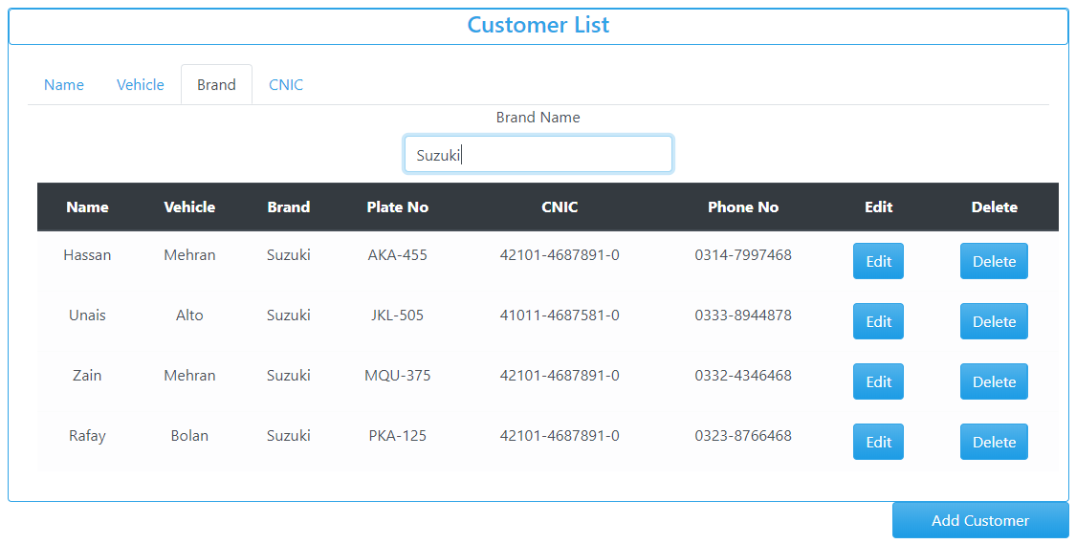

Figure 1: ADD, EDIT, DELETE Button

In Figure 1: In figure edit delete and add button are shown by pressing it they will perform add delete edit functions respectively.

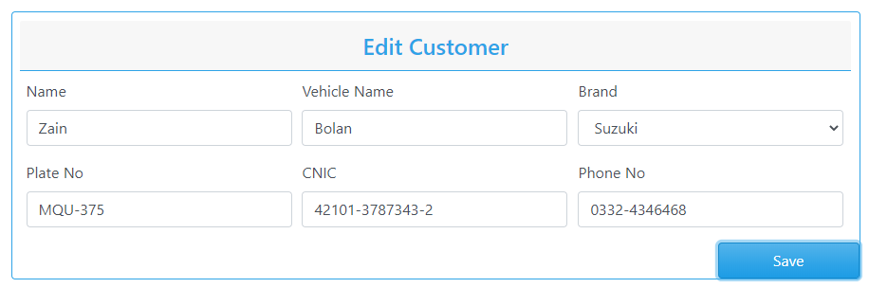

Figure 3: Save Button

Figure 2: Submit Button

In Figure 3: In figure submit button is shown by pressing it they will perform submit function.

In Figure 4: In figure save button is shown by pressing it they will save function.

### 

### Category:

The type or the category of it is clickable (selectable)

### Test cases (step based):

1. Do check appropriate TEXT associated with the button or not.?

**Steps:**

a: Open add customer

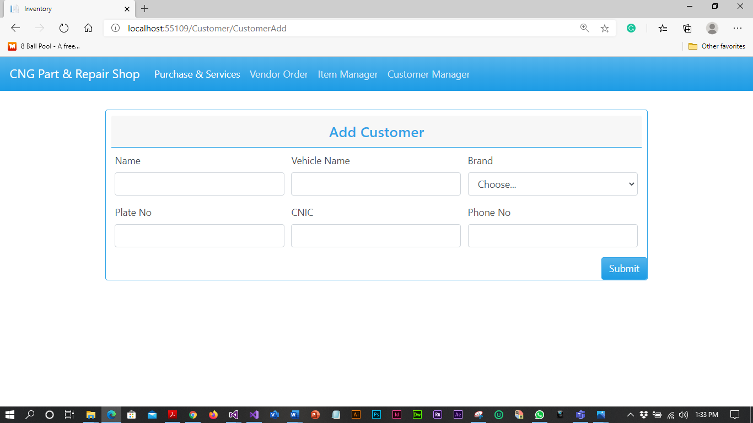

Figure 4:Empty customer add interface

b: Filled customer information



Figure 5: Filled customer add interface

c: After pressing submit button customer is added to the system



Figure 6: customer added

### Guidelines

* Does a text no more than three words in length with all significant first letters capitalized? The use of text is recommended over graphics, it provides a more consistent interface with standard applications.
* Do check whether expected result is displayed on click?
* Do Check the font size of button?
* Do Check the font color of button?
* Do Check the size of button?
* Check the spelling mistake of the label of the button?
* Do buttons labeled with mixed case text that describes the button's behavior, graphics that are easily interpreted, or a combination of both?
* Does a command button process triggers when a mnemonic is selected?
* Do the command buttons are logically grouped? Is this grouping made by white space or not group boxes?
* Do all command buttons are of same dimensions?
* When arranging buttons, do most frequently used buttons located in preferred locations (without violating consistency of location)?
* When arranged left-to-right, do more frequent actions place on the left?
* When arranged vertically, do more frequent actions place at the top?
* Does appropriate TEXT associated with the control, checked?
* Does the label of the control have appropriate naming convention?
* Do pointer is displayed busy when the result of clicking a command isn’t instantaneous?
* Do you use same label text and access key, and locate it in approximately the same place in each window when practical if the same command button appears in more than one window?
* Do you use a minimum button width and the standard command button height for the command button with text label?
* Do you vertically stack them to the right of and top-aligned with the other control, or horizontally place them left-aligned under the control if multiple command button interoperates with the same control?
* Do you use narrow, short, or tall command buttons with text labels?
* Do you make the most likely command the default behavior?
* Do you change the button label to the last selection if the most likely command is the last user selection?
* Do you display default command using bold text in the menu?
* Does a process invoked by a command button is not valid or is the button disabled by dimming the text and disallowing the selection?

## **REFERENCES:**

[1]“Graphical UI Testing Checklist”, https://www.stickyminds.com/sites/default/files/article/file/2014/Graphical%20UI%20Testing%20Checklist.pdf

[2] on 31st August 2012 / by minu.podipara, et al. “How to Test Drop down Lists on Websites?” Digital Solutions Provider, www.zyxware.com/articles/4291/how-to-test-drop-down-lists-on-websites.

[3] Atul. “Graphical UI Testing Checklist.” Stickyminds, www.stickyminds.com/sites/default/files/article/file/2014/Graphical%20UI%20Testing%20Checklist.pdf.

**What else not included:**

* Check for RED asterisk for mandatory fields. (as per requirements)
* Enter continuous characters still it stops to enter any character and measure width of the TextBox. It should stop you and width should be as per requirement.
* Enter valid value in mandatory Textbox and save the window. Again come to same window and delete that value and test if it asks for value as it is mandatory
* If value is coming from DB then check if you can edit same.

-

* If value is coming from DB then check if the value is correct and populating correctly.
* SHIFT and Arrow should Select Characters. Selection should also be possible with mouse. Double Click should select all text in box.
* Move the Mouse Cursor over all Enterable Text Boxes. Cursor should change from arrow to Insert Bar.

### Requirements:

In customer add interface control requirements are following:

1. All fields are filled.
2. CNIC must be in correct format.
3. Phone number must be in correct format.
4. Car plate number must be in correct format.
5. When submit button clicked customer are add to the system.
6. Name not exceed 20 character or limit 3 characters.
7. Vehicle name not exceed 12 or limit 2 characters.
8. Care brand should be considered.

### STRATEGY

* Open the interface of add customer.
* Filled all the controlled in an interface related to the customer.
* Clicked the submit button to save the customer.

# Interface Testing

## **Aesthetic Conditions:**

### Contributors

Ali Akbar Channa, [akbarchanna94@gmail.com](mailto:akbarchanna94@gmail.com), Usman Institute of Technology.

**Purpose**The purpose is to better understand how user interacts with product and to improve product based on the results. The purpose of this test is improving the design in a typical aesthetic test. The real users try to accomplish typical goals or task with a product under controlled condition.



Figure 1 Add customer Interface

**Category:**

Input Base.

**Test case (input Based)**

**User Error**

|  |  |  |  |
| --- | --- | --- | --- |
| Controls | Input | Output | Valid /Invalid |
| Text box | Value exceeds | Alert | Invalid |
| Text box | Out of range | prompt | Valid |

**Multiple validation rules**

|  |  |  |  |
| --- | --- | --- | --- |
| Controls | Input | Output | Valid /Invalid |
| Text box | Once the value is stored it will automatically be appeared as suggestion for second time | duplicate | Valid |

**Numeric validation rules**

|  |  |  |  |
| --- | --- | --- | --- |
| Controls | Input | Output | Valid /Invalid |
| Text box | Matching the data values | Alert out of range | Valid |

**Invalid entry**

|  |  |  |  |
| --- | --- | --- | --- |
| Controls | Input | Output | Valid /Invalid |
| Text box | Special character | Not a number | Valid |
| Text box | Letter | Not a number | Valid |

**Test cases (step based)**

None

**Guide lines**

* Do check whether expected result is displayed on click?
* Do check the font size of button?
* Do check the font color of button?
* Do check the size of button?
* Check the spelling mistake of the label of the button?
* Does appropriate TEXT associated with the control, checked?
* Does the label of the control have appropriate naming convention?
* Does the general screen background the correct color is selected?
* Do the field prompts the correct color?
* Does the field backgrounds the correct color?
* Do read-only mode, are the field prompts the correct color?
* Do read-only mode, are the field backgrounds the correct color?
* Does the screen of all prompts specified in the correct screen font?
* Do the text in all fields specified in the correct screen font?
* Does the field for all prompts aligned perfectly on the screen?
* Does field all the edit boxes aligned perfectly on the screen?
* Does all group boxes aligned correctly on the screen?
* Does the screen can be resizable?
* Does the screen can be minimized?
* Do all the field prompts spelt correctly?
* Does all character or alpha-numeric fields left justified? This is the default unless otherwise specified.
* Does all numeric fields’ right justified? This is the default unless otherwise specified.
* Does all the micro help text spelt correctly on this screen?
* Does all the error message text spelt correctly on this screen?
* Do all user input captured in UPPER case or lower case consistently?
* Does the database requires a value (other than null) then this should be defaulted into fields?
* The user must either enter an alternative valid value or leave the default value intact?
* Do it assure that all windows have a consistent look and feel?
* Do it assure that all dialog boxes have a consistent look and feel?

1. **Validation Conditions**

### Contributors

Ali Akbar Channa, [akbarchanna94@gmail.com](mailto:akbarchanna94@gmail.com), Usman Institute of Technology.

**Purpose**The purpose of data validation is to detect and then verify any data values that may not represent actual Values Effective data validation procedures usually are handled completely independently from the procedures of initial data collection. Moreover, it is advisable that the individuals responsible for data validation not be directly involved with data collection.



Figure 1 Add customer Interface

**Category:**

Input Base.

**Test case (input Based)**

1. **Input Number**

* Verify that lowest and highest values are handled correctly.
* Verify that invalid values are logged and reported
* Verify that valid values are handles by the correct procedure
* Verify that numeric fields with a blank in position 1 are processed or reported as an error.
* Verify that fields with a blank in the last position are processed or reported as an error an error.
* Verify that both + and-values are correctly processed.

2. **Input Date:**

* Verify that leap years are validated correctly & do not cause errors/miscalculations.
* Verify that month code 00 and 13 are validated correctly & do not cause errors/miscalculations
* Verify that month values 00 and 13 are reported as errors
* Verify that day values 00 and 32 are validated correctly & do not cause errors/miscalculations.

3. **Input Alpha fields:**

* Verify for blank and non-blank data.
* Verify Including lowest and highest values.
* Verify Including invalid characters & symbols.
* Verify Including valid characters.
* Verify Including data items with first position blank

1. failure of validation in Name

|  |  |  |  |  |
| --- | --- | --- | --- | --- |
| Controls | Field/control | Input | Output | Valid /Invalid |
| Failure of validation | Name | Mustansar Hussain tarrar Rizvi | Textbox filled red display | Invalid |
| Text box | Name | Mustansar Hussain tarrar | Textbox filled green display | Valid |

1. failure of validation of insert of Dot

|  |  |  |  |  |
| --- | --- | --- | --- | --- |
| Controls | Field/control | Input | Output | Valid /Invalid |
| failure of validation | Dot | Hasssan.Shoaib | Textbox filled red display | Invalid |
| Text box |  | Hassan | Textbox filled green display | Valid |

1. failure of validation of Numeric

|  |  |  |  |  |
| --- | --- | --- | --- | --- |
| Controls | Field/control | Input | Output | Valid /Invalid |
| failure of validation | Numeric | Unais123 | Textbox filled red display | Invalid |
| Text box |  | Unais Zahid | Textbox filled green display | Valid |

1. failure of validation of Special Character

|  |  |  |  |  |
| --- | --- | --- | --- | --- |
| Controls | Field/control | Input | Output | Valid /Invalid |
| Failure of validation | Special Character | Anas@# | Textbox filled red display | Invalid |
| Text box |  | Anas | Textbox filled green display | Valid |

1. failure of validation of Arithmetic Input

|  |  |  |  |  |
| --- | --- | --- | --- | --- |
| Controls | Field/control | Input | Output | Valid /Invalid |
| Failure of validation | Arithmetic Character | 123315 | Textbox filled red display | Invalid |
| Text box |  | Unais | Textbox filled green display | Valid |

1. failure of validation of Alphanumeric

|  |  |  |  |  |
| --- | --- | --- | --- | --- |
| Controls | Field/control | Input | Output | Valid /Invalid |
| Failure of validation | Alpha-Numeric | ASK-01@ | Textbox filled red display | Invalid |
| Text box |  | ASK-201 | Textbox filled green display | Valid |

**Test cases (step based)**

None

**Guide lines**

* Do check whether textbox is filled red color when error?
* Does the test field input limit to 20 characters?
* Does the Require data is saves
* Do it provide all the text boxes with appropriate tittle to make sure that data is filled correct?
* Does alpha numeric has limit?
* Do name enter when dot is placed between them?
* Does a failure of validation on every field cause a sensible user error message?
* Does the user required to fix entries which have failed validation tests?
* Does any fields have multiple validation rules and if so are all rules being applied?
* Do the user enters an invalid value and clicks on the OK button (i.e. does not TAB off the field) is the invalid entry identified and highlighted correctly with an error message?
* Does validation consistently applied at screen level unless specifically required at field level?
* Do all numeric fields check whether negative numbers can and should be able to be entered?
* Does all numeric fields check the minimum and maximum values and also some mid-range values allowable?
* Do all character/alphanumeric fields check the field to ensure that there is a character limit specified and that this limit is exactly correct for the specified database size?
* Do all mandatory fields require user input?
* If any of the database columns don't allow null values then the corresponding screen fields must be mandatory. (If any field which initially was mandatory has become optional then check whether null values are allowed in this field.)

## **Navigation Condition**

### Contributors

Ali Akbar Channa, [akbarchanna94@gmail.com](mailto:akbarchanna94@gmail.com), Usman Institute of Technology.

**Purpose**  
The purpose of navigation to select the option which is given to the users is enable for that interface at a time when to navigate? And where user will go? The primarily purpose to test the navigation is to provide the valid interfaces where user will go through for looking up their information. The background of testing the navigation for the user to allow operations for the legitimate user to manipulates the data from the given information

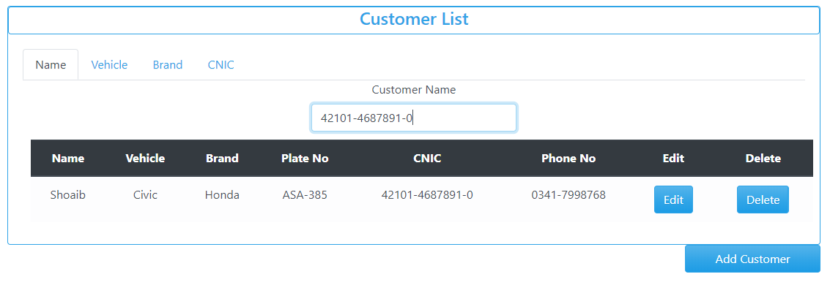

*Figure 1 Customer list Interface with sub menu Customer Name, Vehicle, Brand and CNIC*

**Category:**

Selection Base

**Test case (input Based)**

1. Does screen select from Sub Menu?

|  |  |  |  |
| --- | --- | --- | --- |
| Controls | Input | Output | Valid /Invalid |
| Screen Select from Menu | E:\Black box testing\Search Date.PNG  Select Date from Purchase item & Service List. | Display Required result | Valid |

**User Error**

|  |  |  |  |
| --- | --- | --- | --- |
| Controls | Input | Output | Valid /Invalid |
| Text box | Value exceeds | Alert | Invalid |
| Text box | Out of range | prompt | Valid |

**Multiple validation rules**

|  |  |  |  |
| --- | --- | --- | --- |
| Controls | Input | Output | Valid /Invalid |
| Text box | Once the value is stored it will automatic appeared as suggestion for second time | duplicate | Valid |

**Numeric validation rules**

|  |  |  |  |
| --- | --- | --- | --- |
| Controls | Input | Output | Valid /Invalid |
| Text box | Matching the data values | Alert out of range | Valid |

**Invalid entry**

|  |  |  |  |
| --- | --- | --- | --- |
| Controls | Input | Output | Valid /Invalid |
| Text box | Special character | Not a number | Valid |
| Text box | Letter | Not a number | Valid |

**Guidelines**

* Select the Valid option. Roll back to the first option Does the screen be accessed correctly from the menu?
* Does the screen be accessed correctly from the toolbar?
* Does the screen be accessed correctly by double clicking on a list control on the previous screen?
* Does screens accessible via buttons on this screen be accessed correctly?
* Do all screens accessible by double clicking on a list control be accessed correctly?
* Does screen model is the user prevented from accessing other functions when this screen is active and is this correct?
* Do a number of instances of this screen be opened at the same time and is this correct?
* Does edit button Validate to edit the data?
* Does delete button Validate to delete the data?

## **USABILITY TESTING:**

### Contributors

Ali Akbar Channa, [akbarchanna94@gmail.com](mailto:akbarchanna94@gmail.com), Usman Institute of Technology.

**Purpose**

Ease of use is often the biggest factor in the success of any kind of software, web service or mobile app, and navigation tests are great for measuring this in your interface design. They’re simple and to the point—we show users a screen and ask them how they would complete an action. Then we measure how many users manage it, and how quickly



*Figure 1 Customer list Interface with sub menu Customer Name, Vehicle, Brand and CNIC*

**Test case (Input Based)**

1. The dropdowns on this screen sorted correctly? Alphabetic sorting is the default unless otherwise specified?

|  |  |  |  |
| --- | --- | --- | --- |
| Controls | Input | Output | Valid /Invalid |
| Alphabetic sorting in dropdown screen | Select dropdown from |  | Invalid |

1. The cursor be placed in read-only fields by clicking in the field with the mouse?

|  |  |  |  |
| --- | --- | --- | --- |
| Controls | Input | Output | Valid /Invalid |
| Cursor be placed in read-only fields by clicking in the field with the mouse? | Select the field | Read Only | Valid |

1. Does edit button work correctly?
2. Does delete button work correctly

|  |  |  |  |
| --- | --- | --- | --- |
| Controls | Input | Output | Valid /Invalid |
| Edit and Delete data |  | Data is edited and Deleted. | Valid |

1. There a default button specified on the screen?

|  |  |  |  |
| --- | --- | --- | --- |
| Controls | Input | Output | Valid /Invalid |
| Default Button | No Default Button | None | Invalid |

1. The user Alt+Tab's to another application does this have any impact on the screen upon return to the application

|  |  |  |  |
| --- | --- | --- | --- |
| Controls | Input | Output | Valid /Invalid |
| Alt+Tab's | .  Press Alt+Tab's | No Impact Work Fine. | Valid |

**Test case (step Based)**

STEP 1: All the GUI elements for size, position, width, length, and acceptance of click on a particular button.

STEP 2: you can execute the intended functionality of the control using the MENU...

STEP 3: Check the positioning of GUI elements for different screen resolution.

STEP 4: Verify that the user must not get frustrated while using the control interface

**Guidelines**

* Does a text no more than three words in length with all significant first letters capitalized? The use of text is recommended over graphics, it provides a more consistent interface with standard applications.
* Do check whether expected result is displayed on click?
* Do check the font size of button?
* Does all the dropdowns on this screen sorted correctly? Alphabetic sorting is the default unless otherwise specified.
* Do all date entry required in the correct format?
* Does all pushbuttons on the screen been given appropriate Shortcut keys?
* Do the Shortcut keys work correctly?
* Does the menu options which apply to your screen have fast keys associated and should they have?
* Does the Tab Order specified on the screen go in sequence from Top Left to bottom right this is the default unless otherwise specified?
* Does all read-only fields avoided in the TAB sequence?
* Does all disabled fields avoided in the TAB sequence?
* Do the cursor be placed in the micro help text box by clicking on the text box with the mouse?
* Does the cursor be placed in read-only fields by clicking in the field with the mouse?
* Do the cursor positioned in the first input field or control when the screen is opened?
* Do there a default button specified on the screen?
* Does the default button work correctly?
* Does an error message occurs does the focus return to the field in error when the user cancels it?
* Does the user Alt+Tab's to another application does this have any impact on the screen upon return to the application?
* Do all the fields edit boxes indicate the number of characters they will hold by there length? e.g. a 30 character field should be a lot longer?
* Does edit button work correctly?
* Does delete button work correctly?

1. **Data Integrity Conditions**

### Contributors

Ali Akbar Channa, [akbarchanna94@gmail.com](mailto:akbarchanna94@gmail.com), Usman Institute of Technology.

**Purpose**

The purpose of data integrity is that data integrity refers to the maintenance and assurance of the accuracy and consistency of data. It is the characteristic of information to maintain unaltered and intact between transfer, storage, and usage.



*Figure 1 Customer list Interface with all data of Customer Name, Vehicle, Brand and CNIC*

**Test cases (Input based)**

1. Check whether or NOT a blank value or default value can be retrieved from the database?

|  |  |  |  |
| --- | --- | --- | --- |
| Controls | Input | Output | Valid /Invalid |
| Blank Space Check |  |  | Valid |

1. verify that you can create, modify, and delete any data in tables

|  |  |  |  |
| --- | --- | --- | --- |
| Controls | Input | Output | Valid /Invalid |
| Verify Edit and Delete data |  | Data is edited and Deleted. | Valid |

1. Null values should not be allowed for the Primary key column?

|  |  |  |  |
| --- | --- | --- | --- |
| Controls | Input | Output | Valid /Invalid |
| Null Value |  | Textbox filled red display | Valid |

**Guidelines**

* Does the selected data provide the correct result?
* Does the user data is integrated?
* Does it allow the user to enter the blank data?
* Does the retrieve data same as save data?
* Does the data can retrieve correct after shutdown?
* Do it save as Upper Letter of name?
* Does the Save and Next Command button proceed the further data into database?
* Do all field provide the data and data like N.I.C is more secure?
* Do check whether or NOT a blank value or default value can be retrieved from the database?
* Does it validate each value if it is successfully saved to the database?
* Do it ensuring the data compatibility against old hardware or old versions of operating systems?
* Does it verifying the data in data tables can be modified and deleted?
* Does running data tests for all data files, including clip art, tutorials, and templates?
* Does it verify that you can create, modify, and delete any data in tables?
* Does it verify that sets of radio buttons represent fixed sets of values?
* Does it verify that a blank value can be retrieved from the database?
* Does it verify that, when a particular set of data is saved to the database, each value gets saved fully, and the truncation of strings and rounding of numeric values do not occur?
* Do it verify that the default values are saved in the database, if the user input is not specified?
* Do it verify compatibility with old data, old hardware, versions of operating systems, and interfaces with other software?
* Does it provide data integrity and Data should be stored in single or multiple tables based on the design?
* Does Data should be rolled back in case of failed transactions?
* Does Input field leading and trailing spaces should be truncated before committing data to the database?
* Does Null values should not be allowed for the Primary key column?

## **Feedback**

### Contributors

Ali Akbar Channa, [akbarchanna94@gmail.com](mailto:akbarchanna94@gmail.com), Usman Institute of Technology.

**Purpose**

A person must have to fill in a column a required field entry, system should accept valid entry, when you have entered whole information of customer you will choose the brand, if you have committed a fault you must edit the entry or delete the entry

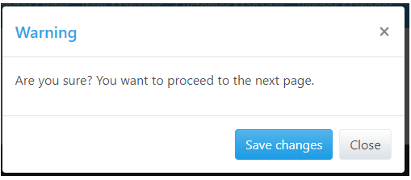

Figure 1: feedback message of command button

**Category:**

Input Base.

**Test case (Input Based)**

Ensure that an error message is displayed on submitting the form by leaving the mandatory fields empty. Expected error messages for the above example is:

"Your name field is required."

"Your Vehicle name field is required."

"Brand field is required."

"CNIC field is required."

"Plate Number field is required."

**Name field:**

Ensure that the system accepts valid name. If the field is customized, then test accordingly.

Ensure that the system rejects the invalid name (input:*##456456@#).

**Vehicle**

Ensure that the system accepts valid Vehicle. For example; Vehicle: Civic should be accepted.

Ensure that the system rejects invalid Vehicle. For example; inputs

"@Civic" should not be accepted

**Brand**

Ensure that the system accepts the valid Brand. Usually consist of alphabets will be accepted. If there is any other specifications like character limits etc., check that as well.

**Plate Number**

Ensure that the system accepts valid Plate number. Usually all alphanumeric entries will be accepted. If there is any other specifications like character limits etc., check that as well.

**Edit button:**

Ensure that the spelling and position of the button is correct.

Ensure that the button is clickable.

Ensure that on submitting a valid form, the value get saved and administrator receives the same data

**Delete button:**

Ensure that the spelling and position of the button is correct.

Ensure that the button is clickable.

Ensure that on delete an entry should be updated in the system

1. Does a person fill anything its mandatory fields should be entered

|  |  |  |  |
| --- | --- | --- | --- |
| Controls | Input | Output | Valid /Invalid |
| Fill mandatory fields |  | Textboxes filled red if blank fields are left | Valid |

**Test case (step Based)**

None

**Guide lines**

Does a person fill anything its mandatory fields should be entered?

Does it should be validated that a system accepts valid entry?

Does the Data should be rolled back in case of failed transactions?

Does it pop a message if user input invalid data multiple times?

Does it should must provide option for edit data if fault occurs?

## **Modes**

### Contributors

Ali Akbar Channa, [akbarchanna94@gmail.com](mailto:akbarchanna94@gmail.com), Usman Institute of Technology.

**Purpose**

The purpose of modes condition is to detect and then verify any data values at the required system. This allow user to editable read only modes and check that the read-only mode is valid.



*Figure 1 Customer list Interface Shows read only mode in table*

**Category:**

Input Base.

**Test cases (input based)**

**Test cases (step based)**

None

1. Check for error messages, for example, « invalid entry, Please, enter valid data» in case of incorrect entry operation

|  |  |  |  |
| --- | --- | --- | --- |
| Controls | Input | Output | Valid /Invalid |
| Error Message | Invalid Input | Textbox filled red display | Valid |

1. Check the right template sizes are shown in a good manner?

|  |  |  |  |
| --- | --- | --- | --- |
| Controls | Input | Output | Valid /Invalid |
| Checking Template Size | Brand name |  | Valid |

**Guide line**

* Does it check the correctness of the app?
* Do it make sure the required fields are not displayed on the screen as optional?
* Does it ensure the software goes into the background in the case of a deleting record?
* Does it ensure that the software cannot shuts if the networks make disconnected?
* Do it make sure the application automatic startup is correct?
* Does it check for error messages, for example, « invalid entry lease, enter valid data» in case of incorrect entry operation?
* Does the screen and field colors adjust correctly for read-only mode?
* Do a read-only mode be provided for this screen?
* Does all fields and controls disable in read-only mode?
* Does the screen be accessed from the previous screen/menu/toolbar in read-only mode?
* Does all screens available from this screen be accessed in read-only mode?
* Does it check that no validation is performed in read-only mode?
* Do it confirm that software Logo ought not to be blurred and title of the software ought not to be incorrectly spelled?
* Does check the right template sizes are shown in a good manner?
* Does it check for error messages, for example, « invalid entry, Please, enter valid data» in case of incorrect entry operation

**2. Is the user required to fix entries which have failed validation tests?**

NO

## **General Condition**

### Contributors

Ali Akbar Channa, [akbarchanna94@gmail.com](mailto:akbarchanna94@gmail.com), Usman Institute of Technology.

**Purpose**

A general condition agreement is a set of regulations which users must agree to follow in order to use a service of mobiles and webs. It is basically to inform users:

* The guidelines of using your website or mobile app, what happens if users are abusing your website or mobile app. that you are the owner of such content
* The content you own is protected by international copyright laws. that abusive accounts will be terminated and banned from using the service.
* The owner can’t be held responsible for any errors in the content presented, or for the information provided being accurate, complete, or suitable for any purpose

**Category:**

Input Base.

**Test cases (input based)**

* 1. All read-only fields avoided in the TAB sequence?

|  |  |  |  |
| --- | --- | --- | --- |
| Controls | Input | Output | Valid /Invalid |
| Read-only fields avoided in the TAB sequence | Apply Tab sequence to read-only |  | Valid |

* 1. The cursor be placed in read-only fields by clicking in the field with the mouse?

|  |  |  |  |
| --- | --- | --- | --- |
| Controls | Input | Output | Valid /Invalid |
| Cursor be placed in read-only fields by clicking in the field with the mouse? | Select the field | Read Only | Valid |

* 1. Does edit button work correctly?
  2. Does delete button work correctly?

|  |  |  |  |
| --- | --- | --- | --- |
| Controls | Input | Output | Valid /Invalid |
| Edit and Delete data |  | Data is edited and Deleted. | Valid |

* 1. There a default button specified on the screen?

|  |  |  |  |
| --- | --- | --- | --- |
| Controls | Input | Output | Valid /Invalid |
| Default Button | No Default Button | None | Invalid |

* 1. All fonts to be the same?

|  |  |  |  |
| --- | --- | --- | --- |
| Controls | Input | Output | Valid /Invalid |
| Font Size |  | None | Valid |

**Test cases (step based)**

None

**Guidelines**

1. Does it assure the existence of the "Help" menu?
2. Does it assure that the proper commands and options are in each menu.
3. Does it assure that all buttons on all tool bars have a corresponding key commands?
4. Does it assure that each menu command has an alternative (hot-key) key sequence which will invoke it where appropriate?
5. Does the drop down list boxes, ensure that the names are not abbreviations / cut short?
6. Does the drop down list boxes, assure that the list and each entry in the list can be accessed via appropriate key / hot key combinations?
7. Does it ensure that duplicate hot keys do not exist on each screen
8. Does it ensure the proper usage of the escape key (which is to undo any changes that have been made) and generates a caution message "Changes will be lost - Continue yes/no"
9. Does it assure that the cancel button functions the same as the escape key?
10. Does it assure that the Cancel button operates as a Close button when changes have be made that cannot be undone?
11. Does it assure that only command buttons which are used by a particular window, or in a particular dialog box, are present - I.e. make sure they don't work on the screen behind the current screen?
12. Does it assure a command button is used sometimes and not at other times, assure that it is grayed out when it should not be used?
13. Does it assure that OK and Cancel buttons are grouped separately from other command buttons?
14. Does it assure that command button names are not abbreviations.
15. Does it assure that all field labels/names are not technical labels, but rather are names meaningful to system users?
16. Does it assure that command buttons are all of similar size and shape, and same font & font size?
17. Does it assure that each command button can be accessed via a hot key combination?
18. Does it assure that command buttons in the same window/dialog box do not have duplicate hot keys?
19. Does it assure that each window/dialog box has a clearly marked default value (command button, or other object) which is invoked when the Enter key is pressed - and NOT the Cancel or Close button?
20. Does it assure that focus is set to an object/button which makes sense according to the function of the window/dialog box?
21. Does it assure that all option buttons (and radio buttons) names are not abbreviations?
22. Does it assure that option button names are not technical labels, but rather are names meaningful to system users?
23. Does hot keys are used to access option buttons, assure that duplicate hot keys do not exist in the same window/dialog box?
24. Does it assure that option box names are not abbreviations?
25. Does it assure that option boxes, option buttons, and command buttons are logically grouped together in clearly demarcated areas "Group Box"?
26. Does it assure that the Tab key sequence which traverses the screens does so in a logical way?
27. Does it assure consistency of mouse actions across windows?
28. Does it assure that the color red is not used to highlight active objects (many individuals are red-green color blind).
29. Does it assure that the user will have control of the desktop with respect to general color and highlighting (the application should not dictate the desktop background characteristics).
30. Does it assure that the screen/window does not have a cluttered appearance?
31. Does Ctrl + F6 opens next tab within tabbed window?
32. Does Shift + Ctrl + F6 opens previous tab within tabbed window?
33. Does Tabbing will open next tab within tabbed window if on last field of current tab?
34. Does Tabbing will go onto the 'Continue' button if on last field of last tab within tabbed window?
35. Does Tabbing will go onto the next editable field in the window?
36. Does Banner style & size & display exact same as existing windows?
37. Do if we press 8 or less options in a list box, display all options on open of list box - should be no need to scroll?
38. Does errors on continue will cause user to be returned to the tab and the focus should be on the field causing the error. (I.e. the tab is opened, highlighting the field with the error on it)
39. Do pressing continue while on the first tab of a tabbed window (assuming all fields filled correctly) will not open all the tabs?
40. Does on open of tab focus will be on first editable field?
41. Does all fonts to be the same?
42. Does press Alt+F4 will close the tabbed window and return you to main screen or previous screen (as appropriate), generating "changes will be lost" message if necessary?
43. Does micro help text for every enabled field & button?
44. Does it ensure all fields are disabled in read-only mode?
45. Does progress messages on load of tabbed screens?
46. Does the return operates continue?
47. Does the retrieve on load of tabbed window fails window should not open?

Make changes in software only by us

Don’t spoil the rights

## **REFERENCES**

[1] Atul. “Graphical UI Testing Checklist.” Stickyminds, [www.stickyminds.com/sites/default/files/article/file/2014/Graphical%20UI%20Testing%20Checklist.pdf](http://www.stickyminds.com/sites/default/files/article/file/2014/Graphical%20UI%20Testing%20Checklist.pdf).

[2] Bhadauria, Tarun Kumar. “No Automated Testing: Manual Testing Checklist.” *Selenium Software Testing*, www.seleniumtests.com/2014/05/manual-testing-checklist.html.

[3] Borysowich, Craig. “Radio Buttons Checklist.” *Tech*, it.toolbox.com/blogs/craigborysowich/radio-buttons-checklist-102306.

[4] Harris, Andy, and About the Book Author Andy Harris taught himself programming because it was fun. Today he teachers computer science. “How to Create a Radio Button in an HTML5 Form.” *Dummies*, www.dummies.com/web-design-development/site-development/how-to-create-a-radio-button-in-an-html5-form/.

[5]

[“GUI Testing Tutorial: User Interface (UI) TestCases with Examples.”](http:// \“GUI Testing Tutorial: User Interface (UI) TestCases with Examples.\” Guru99, www.guru99.com/gui-testing.html.) *[Guru99](http:// \“GUI Testing Tutorial: User Interface (UI) TestCases with Examples.\” Guru99, www.guru99.com/gui-testing.html.)*[, www.guru99.com/gui-testing.html.](http:// \“GUI Testing Tutorial: User Interface (UI) TestCases with Examples.\” Guru99, www.guru99.com/gui-testing.html.)

[6]

[Amrutha, et al. “180+ Sample Test Cases for Testing Web and Desktop Applications - Comprehensive Software Testing Checklist.”](http:// Amrutha, et al. \“180+ Sample Test Cases for Testing Web and Desktop Applications - Comprehensive Software Testing Checklist.\” Software Testing Help, 30 June 2020, www.softwaretestinghelp.com/sample-test-cases-testing-web-desktop-applications/.[7]\“Data Integrity Testing.\” Tutorialspoint, www.tutorialspoint.com/software_testing_dictionary/data_and_database_integrity_testing.htm.) *[Software Testing Help](http:// Amrutha, et al. \“180+ Sample Test Cases for Testing Web and Desktop Applications - Comprehensive Software Testing Checklist.\” Software Testing Help, 30 June 2020, www.softwaretestinghelp.com/sample-test-cases-testing-web-desktop-applications/.[7]\“Data Integrity Testing.\” Tutorialspoint, www.tutorialspoint.com/software_testing_dictionary/data_and_database_integrity_testing.htm.)*[, 30 June 2020, www.softwaretestinghelp.com/sample-test-cases-testing-web-desktop-applications/.](http:// Amrutha, et al. \“180+ Sample Test Cases for Testing Web and Desktop Applications - Comprehensive Software Testing Checklist.\” Software Testing Help, 30 June 2020, www.softwaretestinghelp.com/sample-test-cases-testing-web-desktop-applications/.[7]\“Data Integrity Testing.\” Tutorialspoint, www.tutorialspoint.com/software_testing_dictionary/data_and_database_integrity_testing.htm.)

[[7]“Data Integrity Testing.”](http:// Amrutha, et al. \“180+ Sample Test Cases for Testing Web and Desktop Applications - Comprehensive Software Testing Checklist.\” Software Testing Help, 30 June 2020, www.softwaretestinghelp.com/sample-test-cases-testing-web-desktop-applications/.[7]\“Data Integrity Testing.\” Tutorialspoint, www.tutorialspoint.com/software_testing_dictionary/data_and_database_integrity_testing.htm.) *[Tutorialspoint](http:// Amrutha, et al. \“180+ Sample Test Cases for Testing Web and Desktop Applications - Comprehensive Software Testing Checklist.\” Software Testing Help, 30 June 2020, www.softwaretestinghelp.com/sample-test-cases-testing-web-desktop-applications/.[7]\“Data Integrity Testing.\” Tutorialspoint, www.tutorialspoint.com/software_testing_dictionary/data_and_database_integrity_testing.htm.)*[, www.tutorialspoint.com/software_testing_dictionary/data_and_database_integrity_testing.htm.](http:// Amrutha, et al. \“180+ Sample Test Cases for Testing Web and Desktop Applications - Comprehensive Software Testing Checklist.\” Software Testing Help, 30 June 2020, www.softwaretestinghelp.com/sample-test-cases-testing-web-desktop-applications/.[7]\“Data Integrity Testing.\” Tutorialspoint, www.tutorialspoint.com/software_testing_dictionary/data_and_database_integrity_testing.htm.)

[8] “Database Testing Checklist:” *ProfessionalQA.com*, www.professionalqa.com/database-testing-checklist.

[9] freeCodeCamp.org. “User Interface Test Automation.” *FreeCodeCamp.org*, FreeCodeCamp.org, 20 Oct. 2017, www.freecodecamp.org/news/user-interface-test-automation-3da36b132077/.

[10]

[Kaur, Hamraj, et al. “Mobile App Testing Tutorials (A Complete Guide with 30+ Tutorials).”](http:// Kaur, Hamraj, et al. \“Mobile App Testing Tutorials (A Complete Guide with 30+ Tutorials).\” Software Testing Help, 30 June 2020, www.softwaretestinghelp.com/beginners-guide-to-mobile-application-testing/.https://www.testbytes.net/blog/test-scenario-GUI-interface/) *[Software Testing Help](http:// Kaur, Hamraj, et al. \“Mobile App Testing Tutorials (A Complete Guide with 30+ Tutorials).\” Software Testing Help, 30 June 2020, www.softwaretestinghelp.com/beginners-guide-to-mobile-application-testing/.https://www.testbytes.net/blog/test-scenario-GUI-interface/)*[, 30 June 2020, www.softwaretestinghelp.com/beginners-guide-to-mobile-application-testing/.](http:// Kaur, Hamraj, et al. \“Mobile App Testing Tutorials (A Complete Guide with 30+ Tutorials).\” Software Testing Help, 30 June 2020, www.softwaretestinghelp.com/beginners-guide-to-mobile-application-testing/.https://www.testbytes.net/blog/test-scenario-GUI-interface/)

[11] “Software Testing and QA Consulting Company.” *Testbytes*, 26 June 2019, www.testbytes.net/.

[12] “Trustpilot Legal - Terms & Conditions.” *Trustpilot*, legal.trustpilot.com/for-reviewers/end-user-terms-and-conditions.

## **Requirements:**

In customer add interface requirements are following:

1. When adding detail are filled the customer must be add to the system.
2. Customer must me edited or deleted.
3. In customer list interface customer must be add through it.
4. In customer list interface search must be perform through it.

## **STRATEGY:**

1. Open add customer interface
2. Filled all detail in that interface
3. Clicked to submit button
4. After click submit button then customer list interface is open
5. In this interface add, edit and delete customer button are function to handle customer management

# Develop a Driver (for single interface)

1. We need to check what data from the database is to be used in this interface and excluding the other data that irrelevant for this transactional interface.
2. Develop the interface whether it is a transactional or single in a way that their required data is being provided to them without depending on the other interfaces.
3. The features or functionalities provide in each of the interfaces is to be present in that driver and they should be working properly and efficiently.
4. The interface layout should not be hindered by it opening in a different application or in a different web browser.
5. The color theme, textboxes, dropdown list, checkboxes and other control should be aligned according to the requirements.
6. For a single interface only the function or feature like the CRUD will be developed for its own transactions.
7. The function mentioned in the sixth point are to be developed in way that they can be attached to same interface as an external source and perform their work properly.
8. The Interface developed may work as a API that can be attached to any application.

**PROPOSED INTERFACE:**

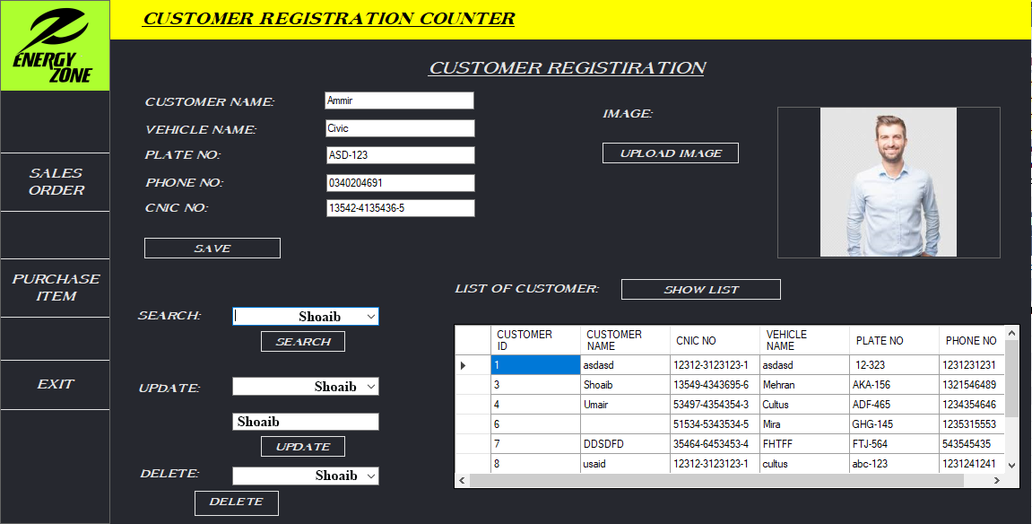

FIGURE :1 GUI PROPESED INTERFACE OF ADD CUSTOMER

# Add Purchase and Service Interface

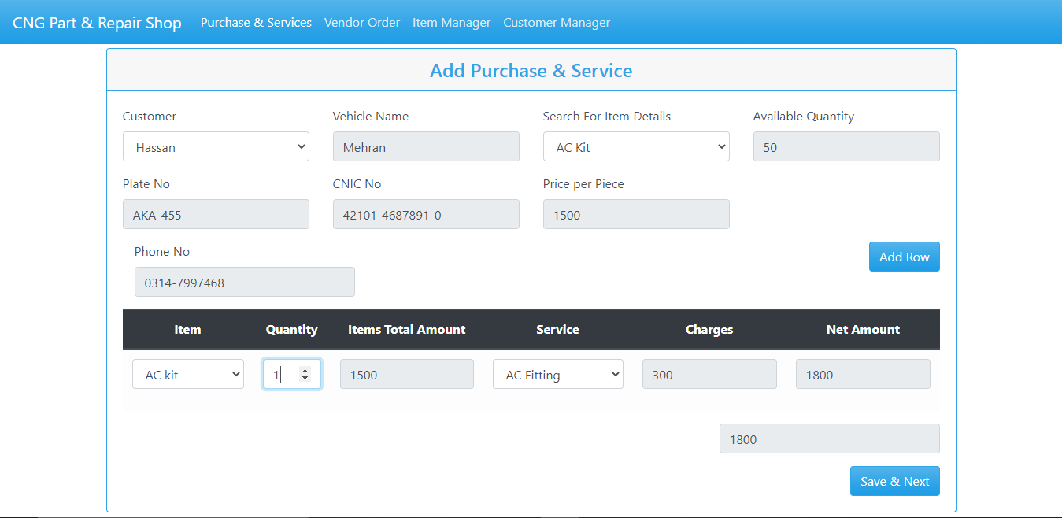

*Figure 1: Add Purchase and Service Interface.*

### List of 3 valid values

|  |  |  |  |
| --- | --- | --- | --- |
| **Control name** | **Valid value 1** | **Valid value 2** | **Valid value 3** |
| Textbox(Alphabetic) | Hassan | HASSAN | Hassan hussain |
| Textbox(Numeric) | 03460-188917 | 03460-189917 | 03460-900917 |
| Textbox(Alpha Numeric) | AKA-455 | ADL-001 | AAA-056 |
| Dropdown | - | - | - |
| Command button | - | - | - |

# Control Testing

### Textbox (Alphanumeric, Numeric, Alphabetic, Formatted)

### Contributors

MUHAMMAD UNAIS, [unaiszahid123@gmail.com](mailto:unaiszahid123@gmail.com) , Usman Institute of technology

**Purpose**

Textbox is a rectangular box which is placed on the interface for taking an input. It is the most common control found in almost any software programs. Textbox is usually used as enter data in it, On clicking the textbox the cursor flashes indicating the text or data can be entered now.

Text box is used to enter and retrieve data to backend database, or can contain in some case default values.

Text box in add purchase and service are used to store different types of data like name, nic, number plate ,item and other which are shown in the figure 1.

**Example**



Figure 2: Textboxes.

**Category:**

Textbox is Input Control base.

**Test case (input Based)**

1. Does the Textbox proceeds when there is no input?
2. Does the Textbox field input Alphabetic data?
3. Does the Textbox field input Numeric data?
4. Does the Textbox field inputs alphanumeric data?
5. Does the CNIC no accepts if 13 digits not provided?
6. Does No Plate given over limit data?
7. Does field allow copy paste or cut options?
8. Does field have limit 20 characters for name?
9. Does field have limit of 12 characters for vehicle name?
10. Does field have min limit of 3 characters for name?
11. Does field allow point values?
12. Does field accept comma between values?
13. Does field provide error when wrong input is provided alphabet in place of numeric value?
14. Does Dropdown provide the required data?
15. Does field accept negative number?

|  |  |  |  |
| --- | --- | --- | --- |
| Test case Name | Input | Output | Valid /Invalid |
| The Textbox proceeds when there is no input |  | Textbox filled red display | Valid |
| The Textbox field input Alphabetic data | HASSAN | Textbox filled green display | Valid |
| the Textbox field input Numeric data | 0332-0578641 | Textbox filled green display | Valid |
| The Textbox field inputs alphanumeric data | AKA-455 | Textbox filled green display | Valid |
| CNIC no accepts if 13 digits not provided | 42301-02111- | Textbox filled red display | Valid |
| No Plate given over limit data | FSS-014 (no more input after 6 ) | Textbox filled green display | Valid |
| Field allow copy paste or cut options | Copy and Paste allow when required data | Textbox filled green display | Valid |
| Field have 20 characters for name | Mustansar Hussain tarrar | Textbox filled green display | Valid |
| Field have 20 characters for name | Mustansar Hussain tarrar Rizvi | Textbox filled red display | Invalid |
| Field have limit of 12 characters for vehicle name | Corolla | Textbox filled green display | Valid |
| Field have min limit of 3 characters for name | Al | Textbox filled red display | Invalid |
| Field allow point values | 15.23 | Textbox filled red display | Invalid |
| Field accepts comma between values | 1621,55 | Textbox filled green display | Valid |
| Field provide error when wrong input is provided alphabet in place of numeric value | Hass167 | Textbox filled red display | Invalid |
| Dropdown provide the required data |  | Textbox filled green display | Valid |
| Field accepts negative number | -15000 | Textbox filled red display | Invalid |

**Test cases (step based)**

None

**Guide lines**

* Does the interface provides all the required information needed for a transition?
* Does textboxes provide the appropriate tittle?
* Does the textbox provide error when inappropriate data is provided?
* Does the alphanumeric input has example to help user?
* Does the name textbox has limit of at least 20 characters?
* Does it save the data when proceed to save and next?
* Does it provide add of item or service at time of invoice if some further parts are added?
* Do invoice show invoice number?
* Does it provide date and time if further necessary?

### Dropdown List Box

### Contributors

MUHAMMAD UNAIS, [unaiszahid123@gmail.com](mailto:unaiszahid123@gmail.com) , Usman Institute of Technology.

### Purpose

The purpose of drop-down list box, users make a choice among a list of mutually exclusive values. Users can choose one and only one option. With a standard drop-down list, users are limited to choices in the list. This help to a quick response in the action of the user.

**Example**

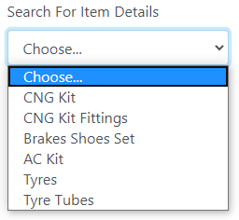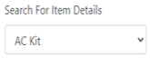

Figure 1 Dropdown list Box

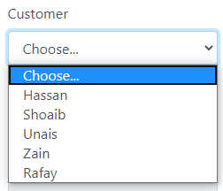

Figure 2 Dropdown list Box

In Figure 2: we have dropdown list box with several option in which we can any option from the given list, such as we have selected car brand.

**Category:**

Selective Controls.

### Test cases (input based):

None

**Test cases (step based)**

* Do click on the arrow of the control and check if list should be displayed?



Figure 3 Customer Name Drop Down List Box

Select any one option from the list



Figure 4 list of appropriate items

**Guide lines**

* Do check drop down displayed (as arrow) over control.
* Do check drop down list is appropriate.
* Do check for default value that should be displayed or it should be BLANK.
* Do check if list contains number of values then “Scroll” option should display and it should be working.
* Do check for alignment of list is associated with control.
* Do check for “TEXT” identifier displayed with the control.
* Do check after clicking on arrow image should display as clicked.
* Does that the drop-down has a proper title.
* Does that the default item is getting displayed when the user first visits the page.
* Does that on clicking the down arrow all items are getting listed in its expected order.
* Does the spelling, font and style of the text inside the drop-down.

### Command Buttons

### Contributors

MUHAMMAD UNAIS, [unaiszahid123@gmail.com](mailto:unaiszahid123@gmail.com) , Usman Institute of Technology.

### Purpose

The command buttons are small rectangle on a graphical user interface with a command, such as open, close, OK, or print, With a command button, users initiate an immediate action by clicking on it .It provides the user a simple way to trigger an event like: SAVE button is used to save the values at the backend or the database. The source of this kind of control is the backend and the type or the category of it is clickable (selectable) because there is no need to input any kind of data and they do not provide any kind of output they only trigger an event of your choice

**Example**

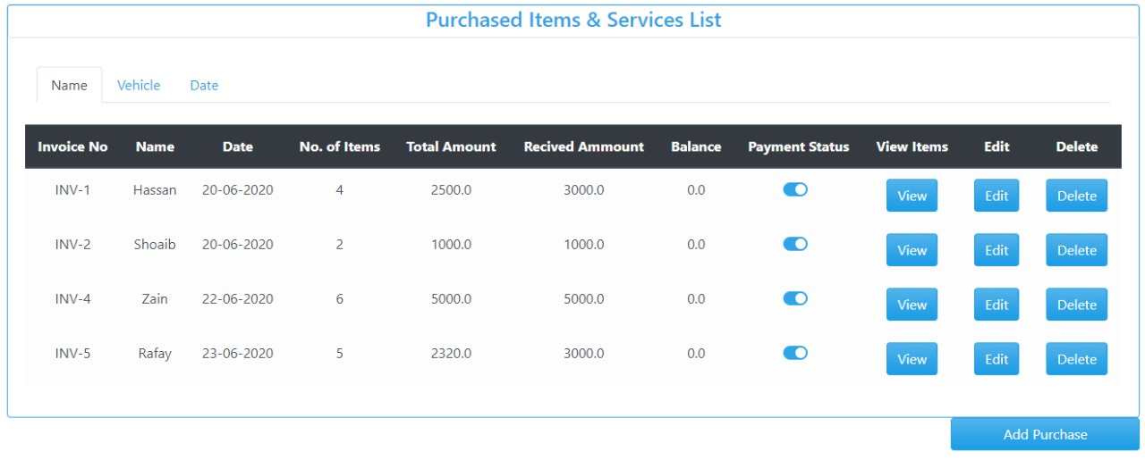

Figure 1 Command Buttons View, Add, Delete and Add Purchase.

**

Figure 2 Command Buttons Add Row and Save and Next.

### Category:

The type is clickable (selectable)

### Test cases (input based):

### None

### Test cases (step based):

* Do check appropriate TEXT associated with the button or not?

**Steps:**

* 1. Filled customer data interface and then save and next to proceed.

**

* 1. Add Purchase button to proceed to further.

 Figure 3 List of the Add Purchase and Service List.

* 1. Interface of Purchase item and services purchased

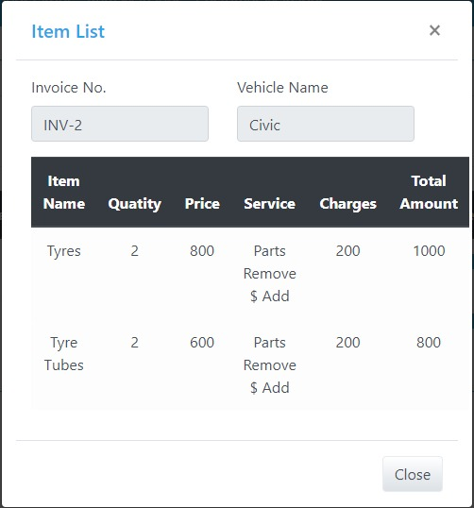

* 1. : Invoice interface of Purchase item and service.

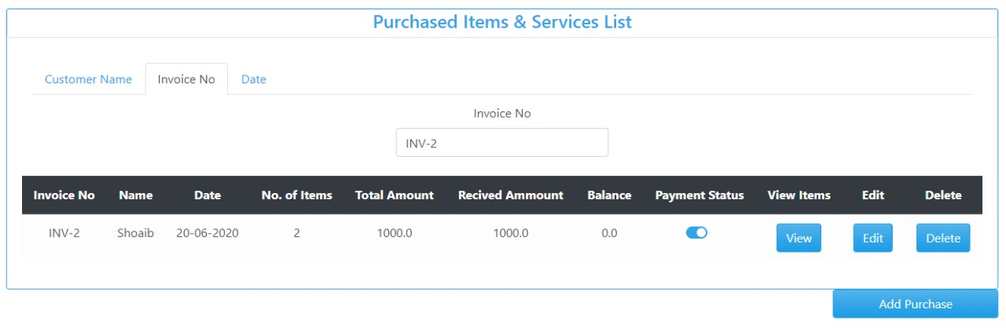 Figure 4 invoice receipt of purchased and service.

### Guidelines

* Do all command buttons are of same dimensions?
* Do check whether expected result is displayed on click?
* Do check the font size of button?
* Do check the font color of button?
* Do check the size of button?
* Do the button proceed further?
* Do all the given button work?
* Do all buttons have appropriate tittle?
* Check the spelling mistake of the label of the button?
* Do you change the button label to the last selection if the most likely command is the last user selection?
* Do you display command button using same text?

## **REFERENCES**

[1]“GraphicalUITestingChecklist”,https://www.stickyminds.com/sites/default/files/article/file/2014/Graphical%20UI%20Testing%20Checklist.pdf

[2] on 31st August 2012 / by minu.podipara, et al. “How to Test Drop down Lists on Websites?” Digital Solutions Provider, [www.zyxware.com/articles/4291/how-to-test-drop-down-lists-on-websites](http://www.zyxware.com/articles/4291/how-to-test-drop-down-lists-on-websites).

[3] Atul. “Graphical UI Testing Checklist.” Stickyminds, www.stickyminds.com/sites/default/files/article/file/2014/Graphical%20UI%20Testing%20Checklist.pdf.

**What else not included:**

Check for RED asterisk for mandatory fields. (as per requirements)

* Enter valid value in mandatory Textbox and save the window. Again come to same window and delete that value and test if it asks for value as it is mandatory
* If value is coming from DB then check if you can edit same. If value is coming from DB then check if the value is correct and populating correctly and should also be possible with mouse. Double Click should select all text in box. Move the Mouse Cursor over all Enterable Text Boxes. Cursor should change from arrow to Insert Bar.

## **Requirements:**

In add purchase control requirements are following:

1. When customer name is selected then customer related fields must be filled in read mode.
2. When item type is selected through item detail then available quantity and price per piece should be show in read mode only.
3. When item is selected then its total amount, service and charges should be show in read mode only.
4. Quantity should be show is same as the available quantity for particular item type.
5. When quantity is selected then total net amount should be show in read mode only.
6. When clicked to add row details must be added to the system.
7. When clicked to save next the details must be saved to the system then invoice is generate.

## **STRATEGY:**

In the Figure 1 the Addition of new item or the service interface is provided to the user where it adds the new purchase item and the services offered by the shop. In this interface the user must provide the required data when all the textboxes filled green it means all data provide is valid and then it saves by pressing the save and next button the fill data is save in the database. In figure 4 one selects the dropdown arrow to show the appropriate data of the required field if any data is useful select from the list as shown in figure 3.The Command button help the user to switch between the different interface help them the to view the data, save, retrieve, edit, retrieve data.

# Interface Testing

### Aesthetic Conditions:

### Contributors

MUHAMMAD UNAIS, [unaiszahid123@gmail.com](mailto:unaiszahid123@gmail.com), Usman Institute of Technology.

**Purpose**The purpose is to understand how the user interacts with product and to improve product based on the results. The purpose of this test is improve the design in a typical aesthetic test. The real user provide the ease to use the interface and also help them to achieve the goal.

**Example**

**Customer Add Purchase and Service**

**

Figure 1 Purchased item and Service Interface.

**Category:**

Input Base.

**Test case (input Based)**

**User Error**

|  |  |  |  |
| --- | --- | --- | --- |
| Controls | Input | Output | Valid /Invalid |
| Text box | Value exceeds | Textbox filled red display | Invalid |
| Text box | Out of range | prompt | Valid |

**Multiple validation rules**

|  |  |  |  |
| --- | --- | --- | --- |
| Controls | Input | Output | Valid /Invalid |
| Text box | Once the value is stored it will automatically be appeared as suggestion for second time | Textbox filled green display | Valid |

**Numeric validation rules**

|  |  |  |  |
| --- | --- | --- | --- |
| Controls | Input | Output | Valid /Invalid |
| Text box | Matching the data values | Alert out of range | Valid |

**Invalid entry**

|  |  |  |  |
| --- | --- | --- | --- |
| Controls | Input | Output | Valid /Invalid |
| Text box | Special character | Not a number | Valid |
| Text box | Letter | Not a number | Valid |

*.*

**Test cases (step based)**

None

**Guide lines**

* Do check whether expected result is displayed on click?
* Do check the font size of button?
* Do check the font color of button?
* Do check the size of button?
* Check the spelling mistake of the label of the button?
* Does appropriate TEXT associated with the control, checked?
* Does the label of the control have appropriate naming convention?
* Does the general screen background the correct color is selected?
* Do the field prompt the correct color?
* Does the field background the correct color?
* Do read-only mode, are the field prompts the correct color?
* Do read-only mode, are the field backgrounds the correct color?
* Does the screen of all prompts specify in the correct screen font?
* Do the text in all fields specified in the correct screen font?
* Does the field for all prompts aligned perfectly on the screen?
* Does field all the edit boxes aligned perfectly on the screen?
* Does all group boxes align correctly on the screen?
* Does the screen can be resizable?
* Does the screen can be minimized?
* Do all the field prompts spelt correctly?
* Does all character or alpha-numeric fields left justified? This is the default unless otherwise specified.
* Do all numeric fields right justify? This is the default unless otherwise specified.
* Does all the micro help text spell correctly on this screen?
* Does all the error message text spell correctly on this screen?
* Do all user input capture in UPPER case or lower case consistently?
* Does the database require a value (other than null) then this should be defaulted into fields?
* The user must either enter an alternative valid value or leave the default value intact?
* Does it assure that all windows have a consistent look and feel?
* Does it assure that all dialog boxes have a consistent look and feel?

1. **Validation Conditions:**

### Contributors

MUHAMMAD UNAIS, [unaiszahid123@gmail.com](mailto:unaiszahid123@gmail.com), Usman Institute of Technology.

**Purpose**

The purpose is to validate the input data that user provide the desire field is valid or invalid which further in data save and other purposes. It is advisable that the individuals responsible for data validation not be directly involved with data collection.

**Example**

**

*Figure 1 Purchased item and Service Interface.*

**Category:**

Input Base.

**Test case (input Based)**

* failure of validation in Name

|  |  |  |  |  |
| --- | --- | --- | --- | --- |
| Controls | Field/control | Input | Output | Valid /Invalid |
| Failure of validation | Name | Mustansar Hussain tarrar Rizvi | Textbox filled red display | Invalid |
| Text box | Name | Mustansar Hussain tarrar | Textbox filled green display | Valid |

* failure of validation of insert of Dot

|  |  |  |  |  |
| --- | --- | --- | --- | --- |
| Controls | Field/control | Input | Output | Valid /Invalid |
| failure of validation | Dot | Hasssan.Shoaib | Textbox filled red display | Invalid |
| Text box |  | Hassan | Textbox filled green display | Valid |

* failure of validation of Numeric

|  |  |  |  |  |
| --- | --- | --- | --- | --- |
| Controls | Field/control | Input | Output | Valid /Invalid |
| failure of validation | Numeric | Unais123 | Textbox filled red display | Invalid |
| Text box |  | Unais Zahid | Textbox filled green display | Valid |

* failure of validation of Special Character

|  |  |  |  |  |
| --- | --- | --- | --- | --- |
| Controls | Field/control | Input | Output | Valid /Invalid |
| Failure of validation | Special Character | Anas@# | Textbox filled red display | Invalid |
| Text box |  | Anas | Textbox filled green display | Valid |

* failure of validation of Arithmetic Input

|  |  |  |  |  |
| --- | --- | --- | --- | --- |
| Controls | Field/control | Input | Output | Valid /Invalid |
| Failure of validation | Arithmetic Character | 123315 | Textbox filled red display | Invalid |
| Text box |  | Unais | Textbox filled green display | Valid |

* failure of validation of Alphanumeric

|  |  |  |  |  |
| --- | --- | --- | --- | --- |
| Controls | Field/control | Input | Output | Valid /Invalid |
| Failure of validation | Alpha-Numeric | ASK-01@ | Textbox filled red display | Invalid |
| Text box |  | ASK-201 | Textbox filled green display | Valid |

**Test cases (step based)**

None

**Guide lines**

* Do check whether textbox is filled red color when error?
* Does the test field input limit to 20 characters?
* Does the Require data is saves
* Does it provide all the text boxes with appropriate tittle to make sure that data is filled correct?
* Does alpha numeric has limit?
* Does name enter when dot is placed between them?
* Does a failure of validation on every field cause a sensible user error message?
* Does the user required to fix entries which have failed validation tests?
* Does any fields have multiple validation rules and if so are all rules being applied?
* Do the user enters an invalid value and clicks on the OK button (i.e. does not TAB off the field) is the invalid entry identified and highlighted correctly with an error message?
* Does validation consistently applied at screen level unless specifically required at field level?
* Do all numeric fields check whether negative numbers can and should be able to be entered?
* Does all numeric fields check the minimum and maximum values and also some mid-range values allowable?
* Do all character/alphanumeric fields check the field to ensure that there is a character limit specified and that this limit is exactly correct for the specified database size?
* Do all mandatory fields require user input?
* If any of the database columns don't allow null values then the corresponding screen fields must be mandatory. (If any field which initially was mandatory has become optional then check whether null values are allowed in this field.)

## **Navigation Condition**

### Contributors

MUHAMMAD UNAIS, [unaiszahid123@gmail.com](mailto:unaiszahid123@gmail.com), Usman Institute of Technology.

**Purpose**  
The purpose of navigation to select the option which is given to the users is enable for that interface at a time when to navigate? And where user will go? The primarily purpose to test the navigation is to provide the valid interfaces where user will go through for looking up their information. The background of testing the navigation for the user to allow operations for the legitimate user to manipulates the data from the given information

**Category:**

Selection Base.

**Example**

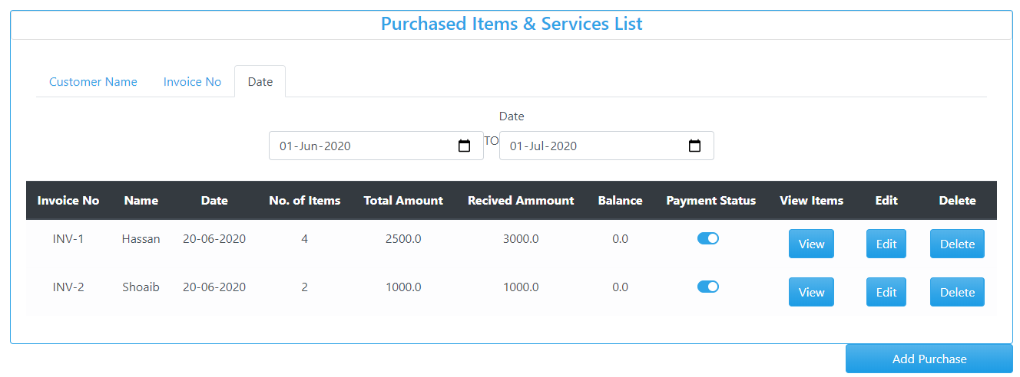

*Figure 1 Purchased item and Service list Interface with sub menu Customer Name, Invoice No, Date(selected).*

**Test case (input Based)**

1. Do screen Select from Menu?

|  |  |  |  |
| --- | --- | --- | --- |
| Controls | Input | Output | Valid /Invalid |
| Screen Select from Menu | E:\Black box testing\2.PNG  Select Purchase & Service. | E:\Black box testing\2.PNGDisplay Required result | Valid |

1. Do screen Select from Sub Menu?

|  |  |  |  |
| --- | --- | --- | --- |
| Controls | Input | Output | Valid /Invalid |
| Screen Select from Menu | E:\Black box testing\Search Date.PNG  Select Date from Purchase item & Service List. | E:\Black box testing\Search Date.PNGDisplay Required result | Valid |

**Test case (step Based)**

None

**Guidelines**

* Does the selected menu provide the result?
* Does it roll back to the first option?
* Does it provide correct tittle?
* Does menu is easily accusable?
* Do the date is provided?
* Does the screen be accessed correctly from the menu?
* Does the screen be accessed correctly from the toolbar?
* Does the screen be accessed correctly by double clicking on a list control on the previous screen?
* Does screens accessible via buttons on this screen be accessed correctly?
* Do all screens accessible by double clicking on a list control be accessed correctly?
* Does screen model is the user prevented from accessing other functions when this screen is active and is this correct?
* Do a number of instances of this screen be opened at the same time and is this correct?
* Does edit button Validate to edit the data
* Does delete button Validate to delete the data

1. **Usability Conditions:**

### Contributors

MUHAMMAD UNAIS, [unaiszahid123@gmail.com](mailto:unaiszahid123@gmail.com), Usman Institute of Technology.

**Purpose**

The purpose of usability is to provide the user an ease of use is often the biggest factor in the success of any kind of software, web service or mobile app, and navigation tests are great for measuring this in your interface design. They’re simple and to the point—we show users a screen and ask them how they would complete an action. Then we measure how many users manage it, and how quickly

**Example**



*Figure 1 Purchased item and Service list Interface with sub menu Customer Name, Invoice No, Date(selected).*

**Category:**

Selection Base.

**Test case (input Based)**

* The dropdowns on this screen sorted correctly? Alphabetic sorting is the default unless otherwise specified?

|  |  |  |  |
| --- | --- | --- | --- |
| Controls | Input | Output | Valid /Invalid |
| Alphabetic sorting in dropdown screen | Select dropdown from | C:\Main Foldf\Downloads\4.PNG | Invalid |

* Date entry required in the correct format?

|  |  |  |  |
| --- | --- | --- | --- |
| Controls | Input | Output | Valid /Invalid |
| Date entry required in the correct format | E:\Black box testing\Search Date.PNG  Select Date from Purchase item & Service List. | E:\Black box testing\Search Date.PNGDisplay Required result | Valid |

* All read-only fields avoided in the TAB sequence?

|  |  |  |  |
| --- | --- | --- | --- |
| Controls | Input | Output | Valid /Invalid |
| Read-only fields avoided in the TAB sequence | Apply Tab sequence to read-only | E:\Black box testing\Search Date.PNG | Valid |

* The cursor be placed in read-only fields by clicking in the field with the mouse?

|  |  |  |  |
| --- | --- | --- | --- |
| Controls | Input | Output | Valid /Invalid |
| Cursor be placed in read-only fields by clicking in the field with the mouse? | Select the field | Read Only | Valid |

* Does edit button work correctly?
* Does delete button work correctly

|  |  |  |  |
| --- | --- | --- | --- |
| Controls | Input | Output | Valid /Invalid |
| Edit and Delete data | E:\Black box testing\Search Date.PNG | Data is edited and Deleted. | Valid |

* There a default button specified on the screen?

|  |  |  |  |
| --- | --- | --- | --- |
| Controls | Input | Output | Valid /Invalid |
| Default Button | No Default Button | None | Invalid |

* The user Alt+Tab's to another application does this have any impact on the screen upon return to the application

|  |  |  |  |
| --- | --- | --- | --- |
| Controls | Input | Output | Valid /Invalid |
| Alt+Tab's | .  Press Alt+Tab's | No Impact Work Fine. | Valid |

**Test case (step Based)**

None

**Guidelines**

* Does the selected dropdown provide the result?
* Do it roll back to the first option?
* Does it provide correct tittle?
* Does it provide correct spell and Grammar?
* Does a text no more than three words in length with all significant first letters capitalized? The use of text is recommended over graphics, it provides a more consistent interface with standard applications?
* Does all the dropdowns on this screen sorted correctly? Alphabetic sorting is the default unless otherwise specified.
* Does all date entry require in the correct format?
* Does all pushbuttons on the screen been given appropriate Shortcut keys?
* Do the Shortcut keys work correctly?
* Do the menu options which apply to your screen have fast keys associated and should they have?
* Does the Tab Order specified on the screen go in sequence from Top Left to bottom right this is the default unless otherwise specified?
* Does all read-only fields avoided in the TAB sequence?
* Does all disabled fields avoided in the TAB sequence?
* Do the cursor be placed in the micro help text box by clicking on the text box with the mouse?
* Does the cursor be placed in read-only fields by clicking in the field with the mouse?
* Do the cursor positioned in the first input field or control when the screen is opened?
* Do there a default button specify on the screen?
* Does the default button work correctly?
* Does an error message occurs does the focus return to the field in error when the user cancels it?
* Do all the fields edit boxes indicate the number of characters they will hold by there length? e.g. a 30-character field should be a lot longer?
* Does edit button work correctly?
* Does delete button work correctly?

## **Data Integrity Conditions**

### Contributors

MUHAMMAD UNAIS, [unaiszahid123@gmail.com](mailto:unaiszahid123@gmail.com), Usman Institute of Technology.

**Purpose**

The purpose of data integrity is that data integrity refers to the maintenance and assurance of the accuracy and consistency of data. It is the characteristic of information to maintain unaltered and intact between transfer, storage, and usage.



*Figure 1 Purchased item and Service list Interface with sub menu Customer Name, Invoice No, Date(selected).*

**Test cases (Input based)**

1. Do check whether or NOT a blank value or default value can be retrieved from the database?

|  |  |  |  |
| --- | --- | --- | --- |
| Controls | Input | Output | Valid /Invalid |
| Blank Space Check | E:\Black box testing\Search Customer Name.PNG | E:\Black box testing\Search Customer Name.PNG | Valid |

1. Do verify that you can create, modify, and delete any data in tables?

|  |  |  |  |
| --- | --- | --- | --- |
| Controls | Input | Output | Valid /Invalid |
| Verify Edit and Delete data | E:\Black box testing\Search Date.PNG | Data is edited and Deleted. | Valid |

1. Do null values should not be allowed for the Primary key column?

|  |  |  |  |
| --- | --- | --- | --- |
| Controls | Input | Output | Valid /Invalid |
| Null Value |  | Textbox filled red display | Valid |

**Test cases (step based)**

None

**Guidelines**

* Does the selected data provide the correct result?
* Does the user data is integrated?
* Does it allow the user to enter the blank data?
* Does the retrieve data same as save data?
* Does the data can retrieve correct after shutdown?
* Do it save as Upper Letter of name?
* Does the Save and Next Command button proceed the further data into database?
* Do all field provide the data and data like N.I.C is more secure?
* Do check whether or NOT a blank value or default value can be retrieved from the database?
* Does it validate each value if it is successfully saved to the database?
* Do it ensuring the data compatibility against old hardware or old versions of operating systems?
* Does it verifying the data in data tables can be modified and deleted?
* Does running data tests for all data files, including clip art, tutorials, and templates?
* Does it verify that you can create, modify, and delete any data in tables?
* Does it verify that sets of radio buttons represent fixed sets of values?
* Does it verify that a blank value can be retrieved from the database?
* Does it verify that, when a particular set of data is saved to the database, each value gets saved fully, and the truncation of strings and rounding of numeric values do not occur?
* Do it verify that the default values are saved in the database, if the user input is not specified?
* Do it verify compatibility with old data, old hardware, versions of operating systems, and interfaces with other software?
* Does it provide data integrity and Data should be stored in single or multiple tables based on the design?
* Does Data should be rolled back in case of failed transactions?
* Does Input field leading and trailing spaces should be truncated before committing data to the database?
* Does Null values should not be allowed for the Primary key column?

## **Feedback**

### Contributors

MUHAMMAD UNAIS, [unaiszahid123@gmail.com](mailto:unaiszahid123@gmail.com), Usman Institute of Technology.

**Purpose**

The purpose is to provide a person must have to fill in a column a required field entry, system should accept valid entry, when you have entered whole information of customer you will choose the brand, if you have committed a fault you must edit the entry or delete the entry and help others to provide more useful service.

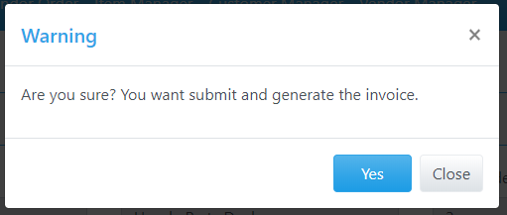

Figure 1 :Feedback messege through command button

**Category:**

Input Base.

**Test case (Input Based)**

Ensure that an error message is displayed on submitting the form by leaving the mandatory fields empty. Expected error messages for the above example is:

"Your name field is required."

"Search for item Details field is required."

**Name field:**

Ensure that the system accepts valid name. If the field is customized, then test accordingly.

Ensure that the system rejects the invalid (Select: *Choose..*).

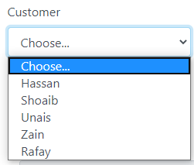

**Search for item Details**

Ensure that the system accepts the valid **Search for item.** If the field is customized, then test accordingly. Ensure that the system rejects the invalid (Select: *Choose. *).

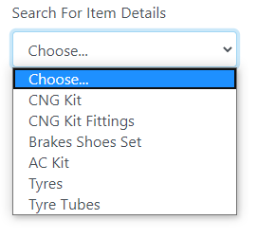

**Edit button:**

Ensure that the spelling and position of the button is correct.

Ensure that the button is clickable.

Ensure that on submitting a valid form, the value get saved and administrator receives the same data

**Delete button:**

Ensure that the spelling and position of the button is correct.

Ensure that the button is clickable.

Ensure that on delete an entry should be updated in the system

1. Does a person fill anything its mandatory fields should be entered?

|  |  |  |  |
| --- | --- | --- | --- |
| Controls | Input | Output | Valid /Invalid |
| Fill mandatory fields | E:\Black box testing\2.PNG | Textboxes filled red if blank fields are left | Valid |

**Test case (step Based)**

None

**Guide lines**

* Does a person fill anything its mandatory fields should be entered?
* Does it should be validated that a system accepts valid entry?
* Does the Data should be rolled back in case of failed transactions?
* Does it pop a message if user input invalid data multiple times?
* Does it should must provide option for edit data if fault occurs?
* Does it ensure that the spelling and position of the button is correct?
* Does it ensure that the button is clickable?
* Does it ensure that on submitting a valid form, the value get saved and administrator receives the same data?
* Does it ensure that the spelling and position of the button is correct?
* Does it ensure that the button is clickable?
* Does it ensure that on delete an entry should be updated in the system?

## **Modes**

### Contributors

MUHAMMAD UNAIS, [unaiszahid123@gmail.com](mailto:unaiszahid123@gmail.com), Usman Institute of Technology.

**Purpose**

The purpose of modes condition is to detect and then verify any data values at the required system. This allow user to editable read only modes and check that the read-only mode is valid.

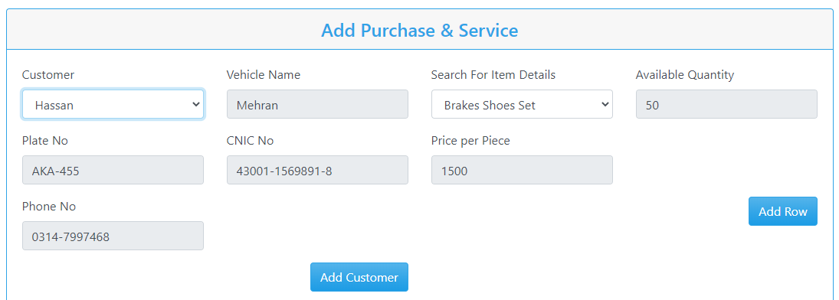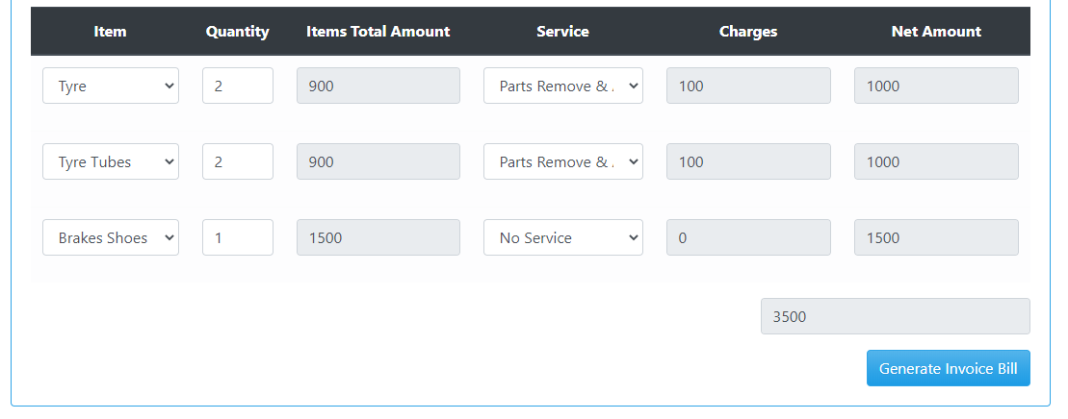

Figure 1: Shows read only mode

**Category:**

Input Base.

**Test cases (input based)**

None

**Test cases (step based)**

1. The screen and field colors adjusted correctly for read-only mode

|  |  |  |  |
| --- | --- | --- | --- |
| Controls | Input | Output | Valid /Invalid |
| The screen and field colors adjusted correctly for read-only mode | Color are read only | None | Valid |

1. Check for error messages, for example, « invalid entry, Please, enter valid data» in case of incorrect entry operation

|  |  |  |  |
| --- | --- | --- | --- |
| Controls | Input | Output | Valid /Invalid |
| Error Message | Invalid Input | Textbox filled red display | Valid |

3. Read-only mode be provided for this screen

|  |  |  |  |
| --- | --- | --- | --- |
| Controls | Input | Output | Valid /Invalid |
| Read-Only for screen | C:\Main Foldf\Downloads\WhatsApp Image 2020-07-04 at 12.10.09 PM.jpeg | C:\Main Foldf\Downloads\WhatsApp Image 2020-07-04 at 12.10.09 PM.jpeg | Valid |

1. Check the right template sizes are shown in a good manner?

|  |  |  |  |
| --- | --- | --- | --- |
| Controls | Input | Output | Valid /Invalid |
| Checking Template Size | Date | E:\Black box testing\Search Date.PNG | Valid |

**Guide line**

* Does it check the correctness of the app?
* Does it make sure the required fields are not displayed on the screen as optional?
* Does it ensure the software goes into the background in the case of a deleting record?
* Does it ensure that the software cannot shuts if the networks make disconnected?
* Does it make sure the application automatic startup is correct?
* Does it check for error messages, for example, « invalid entry lease, enter valid data» in case of incorrect entry operation?
* Does the screen and field colors adjust correctly for read-only mode?
* Do a read-only mode be provided for this screen?
* Does all fields and controls disable in read-only mode?
* Does the screen be accessed from the previous screen/menu/toolbar in read-only mode?
* Does all screens available from this screen be accessed in read-only mode?
* Does it check that no validation is performed in read-only mode?
* Do it confirm that software Logo ought not to be blurred and title of the software ought not to be incorrectly spelled?
* Does check the right template sizes are shown in a good manner?
* Does it check for error messages, for example, « invalid entry, Please, enter valid data» in case of incorrect entry operation

**2. Is the user required to fix entries which have failed validation tests?**

NO

## **8.General Condition**

### Contributors

MUHAMMAD UNAIS, [unaiszahid123@gmail.com](mailto:unaiszahid123@gmail.com), Usman Institute of Technology.

**Purpose**

A general condition agreement is a set of regulations which users must agree to follow in order to use a services of mobiles and webs. It is basically to inform users:

* The guidelines of using your website or mobile app, what happens if users are abusing your website or mobile app. that you are the owner of such content
* The content you own is protected by international copyright laws. that abusive accounts will be terminated and banned from using the service.
* The owner can’t be held responsible for any errors in the content presented, or for the information provided being accurate, complete, or suitable for any purpose

**Test cases (input based)**

* + Do date entry required in the correct format?

|  |  |  |  |
| --- | --- | --- | --- |
| Controls | Input | Output | Valid /Invalid |
| Date entry required in the correct format | E:\Black box testing\Search Date.PNG  Select Date from Purchase item & Service List. | E:\Black box testing\Search Date.PNGDisplay Required result | Valid |

* + Do all read-only fields avoided in the TAB sequence?

|  |  |  |  |
| --- | --- | --- | --- |
| Controls | Input | Output | Valid /Invalid |
| Read-only fields avoided in the TAB sequence | Apply Tab sequence to read-only | E:\Black box testing\Search Date.PNG | Valid |

* + Do the cursor be placed in read-only fields by clicking in the field with the mouse?

|  |  |  |  |
| --- | --- | --- | --- |
| Controls | Input | Output | Valid /Invalid |
| Cursor be placed in read-only fields by clicking in the field with the mouse? | Select the field | Read Only | Valid |

* + Does edit button work correctly?
  + Does delete button work correctly?

|  |  |  |  |
| --- | --- | --- | --- |
| Controls | Input | Output | Valid /Invalid |
| Edit and Delete data | E:\Black box testing\Search Date.PNG | Data is edited and Deleted. | Valid |

* + Do there a default button specified on the screen?

|  |  |  |  |
| --- | --- | --- | --- |
| Controls | Input | Output | Valid /Invalid |
| Default Button | No Default Button | None | Invalid |

* + Do all fonts to be the same?

|  |  |  |  |
| --- | --- | --- | --- |
| Controls | Input | Output | Valid /Invalid |
| Font Size | E:\Black box testing\Search Date.PNG | None | Valid |

* + Do read-only mode be provided for this screen

|  |  |  |  |
| --- | --- | --- | --- |
| Controls | Input | Output | Valid /Invalid |
| Read-Only for screen | C:\Main Foldf\Downloads\WhatsApp Image 2020-07-04 at 12.10.09 PM.jpeg | C:\Main Foldf\Downloads\WhatsApp Image 2020-07-04 at 12.10.09 PM.jpeg | Valid |

**Test cases (step based)**

None

**Guidelines**

* Does it assure the existence of the "Help" menu?
* Does it assure that the proper commands and options are in each menu.
* Does it assure that all buttons on all tool bars have a corresponding key commands?
* Does it assure that each menu command has an alternative (hot-key) key sequence which will invoke it where appropriate?
* Do the drop-down list boxes, ensure that the names are not abbreviations / cut short?
* Do the drop-down list boxes, assure that the list and each entry in the list can be accessed via appropriate key / hot key combinations?
* Does the retrieve on load of tabbed window fails window should not open?
* Does it ensure that duplicate hot keys do not exist on each screen?
* Does it ensure the proper usage of the escape key (which is to undo any changes that have been made) and generates a caution message "Changes will be lost - Continue yes/no"
* Does it assure that the cancel button functions the same as the escape key?
* Does it assure that the Cancel button operates as a Close button when changes have be made that cannot be undone?
* Does it assure that only command buttons which are used by a particular window, or in a particular dialog box, are present - I.e. make sure they don't work on the screen behind the current screen?
* Does it assure a command button is used sometimes and not at other times, assure that it is grayed out when it should not be used?
* Does it assure that OK and Cancel buttons are grouped separately from other command buttons?
* Does it assure that command button names are not abbreviations?
* Does it assure that all field labels/names are not technical labels, but rather are names meaningful to system users?
* Does it assure that command buttons are all of similar size and shape, and same font & font size?
* Does it assure that each command button can be accessed via a hot key combination?
* Does it assure that command buttons in the same window/dialog box do not have duplicate hot keys?
* Does it assure that each window/dialog box has a clearly marked default value (command button, or other object) which is invoked when the Enter key is pressed - and NOT the Cancel or Close button?
* Does it assure that focus is set to an object/button which makes sense according to the function of the window/dialog box?
* Does it assure that all option buttons (and radio buttons) names are not abbreviations?
* Does it assure that option button names are not technical labels, but rather are names meaningful to system users?
* Do hot keys are used to access option buttons, assure that duplicate hot keys do not exist in the same window/dialog box?
* Does it assure that option box names are not abbreviations?
* Does it assure that option boxes, option buttons, and command buttons are logically grouped together in clearly demarcated areas "Group Box"?
* Does it assure that the Tab key sequence which traverses the screens does so in a logical way?
* Does it assure consistency of mouse actions across windows?
* Does it assure that the color red is not used to highlight active objects (many individuals are red-green color blind).
* Does it assure that the user will have control of the desktop with respect to general color and highlighting (the application should not dictate the desktop background characteristics).
* Does it assure that the screen/window does not have a cluttered appearance?
* Does Ctrl + F6 opens next tab within tabbed window?
* Does Shift + Ctrl + F6 opens previous tab within tabbed window?
* Does Tabbing will open next tab within tabbed window if on last field of current tab?
* Does Tabbing will go onto the 'Continue' button if on last field of last tab within tabbed window?
* Does Tabbing will go onto the next editable field in the window?
* Does Banner style & size & display exact same as existing windows?
* Do if we press 8 or less options in a list box, display all options on open of list box - should be no need to scroll?
* Does errors on continue will cause user to be returned to the tab and the focus should be on the field causing the error. (I.e. the tab is opened, highlighting the field with the error on it)
* Do pressing continue while on the first tab of a tabbed window (assuming all fields filled correctly) will not open all the tabs?
* Does on open of tab focus will be on first editable field?
* Does all fonts to be the same?
* Does press Alt+F4 will close the tabbed window and return you to main screen or previous screen (as appropriate), generating "changes will be lost" message if necessary?
* Does micro help text for every enabled field & button?
* Does it ensure all fields are disabled in read-only mode?
* Does progress messages on load of tabbed screens?
* Does the return operates continue?
* Does the retrieve on load of tabbed window fails window should not open?

Make changes in software only by us

Don’t spoil the rights

## **REFERENCES**

[1]Atul.“GraphicalUITestingChecklist.”Stickyminds, [www.stickyminds.com/sites/default/files/article/file/2014/Graphical%20UI%20Testing%20Checklist.pdf](http://www.stickyminds.com/sites/default/files/article/file/2014/Graphical%20UI%20Testing%20Checklist.pdf).

[2] Bhadauria, Tarun Kumar. “No Automated Testing: Manual Testing Checklist.” *Selenium Software Testing*, www.seleniumtests.com/2014/05/manual-testing-checklist.html.

[3] Borysowich, Craig. “Radio Buttons Checklist.” *Tech*, it.toolbox.com/blogs/craigborysowich/radio-buttons-checklist-102306.

[4] Harris, Andy, and About the Book Author Andy Harris taught himself programming because it was fun. Today he teachers computer science. “How to Create a Radio Button in an HTML5 Form.” *Dummies*, www.dummies.com/web-design-development/site-development/how-to-create-a-radio-button-in-an-html5-form/.

[5]

[“GUI Testing Tutorial: User Interface (UI) TestCases with Examples.”](http://\“GUI Testing Tutorial: User Interface (UI) TestCases with Examples.\” Guru99, www.guru99.com/gui-testing.html.) *[Guru99](http://\“GUI Testing Tutorial: User Interface (UI) TestCases with Examples.\” Guru99, www.guru99.com/gui-testing.html.)*[, www.guru99.com/gui-testing.html.](http://\“GUI Testing Tutorial: User Interface (UI) TestCases with Examples.\” Guru99, www.guru99.com/gui-testing.html.)

[6]

[Amrutha, et al. “180+ Sample Test Cases for Testing Web and Desktop Applications - Comprehensive Software Testing Checklist.”](http:// Amrutha, et al. \“180+ Sample Test Cases for Testing Web and Desktop Applications - Comprehensive Software Testing Checklist.\” Software Testing Help, 30 June 2020, www.softwaretestinghelp.com/sample-test-cases-testing-web-desktop-applications/.[7] \“Data Integrity Testing.\” Tutorialspoint, www.tutorialspoint.com/software_testing_dictionary/data_and_database_integrity_testing.htm.) *[Software Testing Help](http:// Amrutha, et al. \“180+ Sample Test Cases for Testing Web and Desktop Applications - Comprehensive Software Testing Checklist.\” Software Testing Help, 30 June 2020, www.softwaretestinghelp.com/sample-test-cases-testing-web-desktop-applications/.[7] \“Data Integrity Testing.\” Tutorialspoint, www.tutorialspoint.com/software_testing_dictionary/data_and_database_integrity_testing.htm.)*[, 30 June 2020, www.softwaretestinghelp.com/sample-test-cases-testing-web-desktop-applications/.](http:// Amrutha, et al. \“180+ Sample Test Cases for Testing Web and Desktop Applications - Comprehensive Software Testing Checklist.\” Software Testing Help, 30 June 2020, www.softwaretestinghelp.com/sample-test-cases-testing-web-desktop-applications/.[7] \“Data Integrity Testing.\” Tutorialspoint, www.tutorialspoint.com/software_testing_dictionary/data_and_database_integrity_testing.htm.)

[[7] “Data Integrity Testing.”](http:// Amrutha, et al. \“180+ Sample Test Cases for Testing Web and Desktop Applications - Comprehensive Software Testing Checklist.\” Software Testing Help, 30 June 2020, www.softwaretestinghelp.com/sample-test-cases-testing-web-desktop-applications/.[7] \“Data Integrity Testing.\” Tutorialspoint, www.tutorialspoint.com/software_testing_dictionary/data_and_database_integrity_testing.htm.) *[Tutorialspoint](http:// Amrutha, et al. \“180+ Sample Test Cases for Testing Web and Desktop Applications - Comprehensive Software Testing Checklist.\” Software Testing Help, 30 June 2020, www.softwaretestinghelp.com/sample-test-cases-testing-web-desktop-applications/.[7] \“Data Integrity Testing.\” Tutorialspoint, www.tutorialspoint.com/software_testing_dictionary/data_and_database_integrity_testing.htm.)*[, www.tutorialspoint.com/software_testing_dictionary/data_and_database_integrity_testing.htm.](http:// Amrutha, et al. \“180+ Sample Test Cases for Testing Web and Desktop Applications - Comprehensive Software Testing Checklist.\” Software Testing Help, 30 June 2020, www.softwaretestinghelp.com/sample-test-cases-testing-web-desktop-applications/.[7] \“Data Integrity Testing.\” Tutorialspoint, www.tutorialspoint.com/software_testing_dictionary/data_and_database_integrity_testing.htm.)

[8] “Database Testing Checklist:” *ProfessionalQA.com*, www.professionalqa.com/database-testing-checklist.

[9] freeCodeCamp.org. “User Interface Test Automation.” *FreeCodeCamp.org*, FreeCodeCamp.org, 20 Oct. 2017, www.freecodecamp.org/news/user-interface-test-automation-3da36b132077/.

[10]

[Kaur, Hamraj, et al. “Mobile App Testing Tutorials (A Complete Guide with 30+ Tutorials).”](http:// Kaur, Hamraj, et al. \“Mobile App Testing Tutorials (A Complete Guide with 30+ Tutorials).\” Software Testing Help, 30 June 2020, www.softwaretestinghelp.com/beginners-guide-to-mobile-application-testing/.https://www.testbytes.net/blog/test-scenario-GUI-interface/) *[Software Testing Help](http:// Kaur, Hamraj, et al. \“Mobile App Testing Tutorials (A Complete Guide with 30+ Tutorials).\” Software Testing Help, 30 June 2020, www.softwaretestinghelp.com/beginners-guide-to-mobile-application-testing/.https://www.testbytes.net/blog/test-scenario-GUI-interface/)*[, 30 June 2020, www.softwaretestinghelp.com/beginners-guide-to-mobile-application-testing/.](http:// Kaur, Hamraj, et al. \“Mobile App Testing Tutorials (A Complete Guide with 30+ Tutorials).\” Software Testing Help, 30 June 2020, www.softwaretestinghelp.com/beginners-guide-to-mobile-application-testing/.https://www.testbytes.net/blog/test-scenario-GUI-interface/)

[11]“Software Testing and QA Consulting Company.” *Testbytes*, 26 June 2019, www.testbytes.net/.

[12]“Trustpilot Legal - Terms & Conditions.” *Trustpilot*, legal.trustpilot.com/for-reviewers/end-user-terms-and-conditions.

## **Requirements:**

In Add Purchase interface requirements are following:

1. Through add purchase info we must go to add customer or generate the invoice bill through invoice bill interface.
2. Invoice must be display
3. Invoice must be view, edit and delete.
4. Record must search through Invoice no, customer name, and date.
5. In invoice bill interface detail must be filled in read mode after clicking generate invoice bill in add purchase interface.

**STRATEGY**:

The Purchase item and Service is selected from the menu then then Add Purchase item and service list interface is appeared for the user where the new customer with desire input text field has to filled, the wrong field fill textboxes turn to red while the correct field that turn to the green then if we need to add another row just simple click on add row if not then proceed to save and next then a list of all the item added to appear if we need to add more item just simple click on add item if not then proceed further and then next to provide the desire purchased item list or the service list then further it proceed for the invoice which is then given to the customer and proceed for further payment.

# Develop a Driver (for transactional interface)

1. We need to check what data from the database is to be used in this interface and excluding the other data that irrelevant for this transactional interface.
2. Develop the interface whether it is a transactional or single in a way that their required data is being provided to them without depending on the other interfaces.
3. The features or functionalities provide in each of the interfaces is to be present in that driver and should be working properly and efficiently.
4. The interface layout should not be hindered by it opening in a different application or in a different web.
5. The color theme, textboxes, dropdown list, checkboxes and other control should be aligned according to the requirements.
6. As for the transactional interfaces there may be some single interface functionalities attached to it, to perform its features correctly and fully.
7. The single interface like Add Vendor its functionalities should be developed as a CRUD module and the Transactional interface like Vendor Order’s functionalities are to be developed by attached the single interfaces required for it.
8. Develop these functionalities as an API to work as a service and run these on the interfaces check whether they are working properly or not.
9. Similar doing the process to develop another interface.

**PROPOSED INTERFACE:**

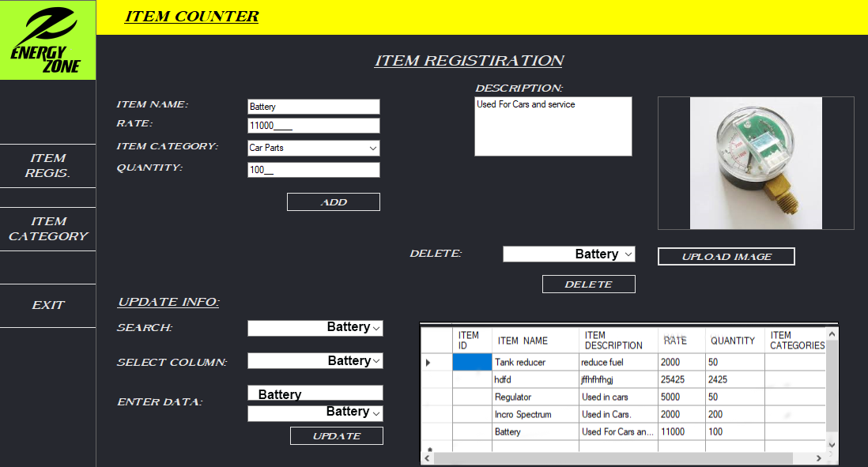

FIGURE :1 GUI PROPESED INTERFACE OF ITEM REGISTRATION

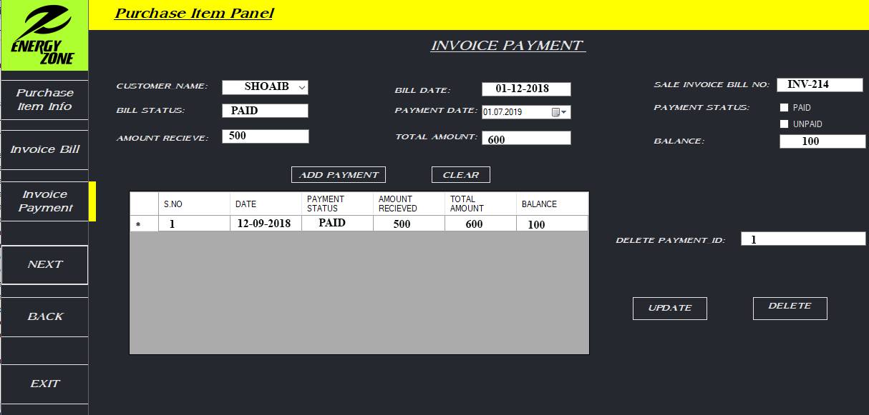

FIGURE :2 GUI PROPESED INTERFACE OF PURCHASE ITEM

# Vendor Order Interface

**

### List of 3 valid values

|  |  |  |  |
| --- | --- | --- | --- |
| Control name | Valid value 1 | Valid value 2 | Valid value 3 |
| Checkbox | True | False |  |
| Button | Onclick | Form values | Id e.g. 11, 1, or1025 etc. |
| Dropdown Box | Item names e.g. CNG Kit, CNG Filling Plug etc. | Customer Names e.g. Hassan, Ahmed or Aamir | Vendor Names e.g. Suzuki |
| Table or Grid | Data from database | Inputting the data of form |  |
| Numeric Textbox | 10 or 20 | 35550 | 700000 |
| Read-only Textbox | 20-Jul-2020 | 42101-4393979-5 | 0347-6797669 |
| Image |  |  |  |

# Control Testing

### Textbox (Read-only, Alphanumeric, Numeric, Alphabetic)

### Contributors

Hassan Ahmed Siddiqui, hassansiddiqi0@gmail.com, Usman Institute of technology

### Purpose

Textbox is a input control that it is a rectangular box which is placed on the interface for taking an input. It is the most common control found in almost any software programs. Textbox is usually used as enter data in it, can take different types of input such as alphanumeric, numeric or alphabetic data in it and can also be formatted according to requirements. On clicking the textbox, the cursor flashes indicating the text or data can be entered now. Text box is used to enter and retrieve data to backend database or can contain in some case default values.

**Example**

Figure 1: Textbox for alpha value

Figure 2: Read-Only Textbox for alphanumeric value

Figure 3: Read-Only Textbox for numeric value

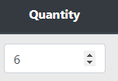**s**

Figure 4: Textbox for numeric value

Figure 5: Textbox for date value

**Figure 1:**  This box is used to search for data through vendor shop name.

**Figure 2:** This box is used for showing the CNIC of customers, which is a read-only textbox.

**Figure 3:** This box is used to show the price per item to know its details. It is also a read-only textbox

**Figure 4:** This textbox is used in grid to enter the quantity of items. It is a number textbox

**Figure 5:** This textbox is for selecting dates for item delivery, it is date textbox

### Category:

Input Control

### Test case (input Based)

### Test case (input Based)

**Read-only:**

1. Do any of the pre-populated value are displayed as per requirement?

|  |  |  |  |
| --- | --- | --- | --- |
| Test case Name | Input | Output | Valid /Invalid |
| Pre-Populated values | Values form database such as Vendor Name: Anas, Shariq etc |  | Valid |
| 10 or 20 i.e. quantity |  | Valid |
| Not loading any values |  | Invalid |

1. Do the formatting in the read-only textboxes are according to the requirements?

|  |  |  |  |
| --- | --- | --- | --- |
| Test case Name | Input | Output | Valid /Invalid |
| Correct format | Value from database;4210-45303354-5 |  | Valid |
| 4210-45303345 |  | Invalid |

1. Does the textbox show the calculated value of the after value entered in other textboxes by triggering an event?

|  |  |  |  |
| --- | --- | --- | --- |
| Test case Name | Input | Output | Valid /Invalid |
| Trigger Event |  |  | Valid |

**Enabled Textboxes:**

1. Do the leap years are validated correctly & do not cause errors/miscalculations?

|  |  |  |  |
| --- | --- | --- | --- |
| Test case Name | Input | Output | Valid /Invalid |
| Leap Year | 29-Feb-2020 |  | Valid |
| 29-Feb-2021 |  | Invalid |

1. Do the month code 01 and 12 are validated correctly & do not cause errors/ miscalculations?

|  |  |  |  |
| --- | --- | --- | --- |
| Test case Name | Input | Output | Valid /Invalid |
| Month code | 17-07-2020 |  | Valid |
| 17-00-2020 |  | Invalid |
| 17-13-2020 |  | Invalid |

1. Do the textboxes accept values equal and between its min and max limit?

|  |  |  |  |
| --- | --- | --- | --- |
| Test case Name | Input | Output | Valid /Invalid |
| Quantity min and max limit | Here the limit for quantity is 15 so, 5 |  | Valid |
| 13 |  | Valid |
| 18 |  |  |

### Test cases (step based)

**Read-only:**

1. Does the read-only textbox cannot be edited?

By clicking on the text, performing other features of the interface even after the textbox remains with read-only property, if not there is an error or bug.

1. Does the cursor display on the disabled Textbox?

Take the cursor on the textbox and see whether it is displayed or not, if not then it is working properly.

1. Does the SHIFT and Arrow select characters and is the selection possible with mouse Double Click for all text in textboxes.

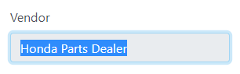

By double clicking the whole text is selected and also by using the shift and arrow keys.

**Enabled Textbox:**

1. Does date textbox show a calendar on clicking on its calendar icon? A screenshot of a cell phone

   Description automatically generated

After clicking the icon it shows a calendar to select a date from it.

1. Does the function displayed in calendar working correctly?

After selecting the feature it seen that whether it is working properly or not.

1. Does it allow to select the values from the calendar?

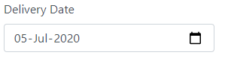

1. Does the cursor start blinking when get focused on the numeric textbox?

### Guidelines

**Read-only:**

1. Does the textbox have the enabled or disabled property as per the requirement?
2. Do the Textbox should be enabled to enter value or remained to be with only read-only values, check for conditions?
3. Do the textboxes are greyed out to show their property?
4. Do check for combination of alphabets, numeric, signs and special characters.
5. Does the value coming from DB is correct and populating correctly?
6. Does the Database accept “Redundant” values?
7. Does the alignment of Textbox and Text associate with Textbox are proper as per other controls on window?
8. Do the textboxes have the correct “Text” associated with them?
9. Does its pre-population any value or BLANK value for textboxes as per requirement?

**Enabled Textbox:**

1. Does it show for RED asterisk for mandatory fields? (as per requirements)
2. Does the coming from DB is editable or not?
3. Does the alignment of Textbox and Text associate with Textbox are proper as per other controls on window?
4. Does century change is validated correctly & does not cause errors/miscalculations? Verify it.
5. Do the dates Feb. 28, 29, 30 are validated correctly & do not cause errors/miscalculations?
6. Does its pre-population any value or BLANK value for textboxes as per requirement?

### Dropdown-Box List

### Contributors

Hassan Ahmed Siddiqui, [hassansiddiqi0@gmail.com](mailto:hassansiddiqi0@gmail.com), Usman Institute of Technology

### Purpose

A drop-down list is a graphical control element, which is quite similar to a list box, that allows the user to select a value from a list of values in the box. When a drop-down list is inactive, it displays the default value or pre-selected value. When activated by clicking it, it drops down a list of values, from which the user may select one, as the user selects a value, the control reverts back to its inactive state, displaying the only selected value. It is mainly used to show data in other textboxes according to the data selected in the

**Example**

Figure 1: Dropdown List for Items

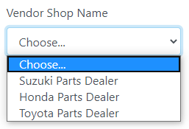

Figure 2: Dropdown List for Vendor Shop Name

**Figure 1:** The figure gives the dropdown list of the items available.

**Figure 2:** This provides the name of the shop the vendor in a dropdown List.

### Category

Graphical control

### Test Cases (Input based)

1. Does it display the default value that should be displayed, or it should be BLANK?

|  |  |  |  |
| --- | --- | --- | --- |
| Test case Name | Input | Output | Valid /Invalid |
| Default Values | Pre-populated Value |  | Valid |
| Blank value |  | Valid |

1. Do the mandatory field can accept BLANK value?

|  |  |  |  |
| --- | --- | --- | --- |
| Test case Name | Input | Output | Valid /Invalid |
| Blank value | Select a value from list |  | Valid |
| Blank value |  | Invalid |

1. Does it contain the correct or incorrect data?

|  |  |  |  |
| --- | --- | --- | --- |
| Test case Name | Input | Output | Valid /Invalid |
| Correct or Incorrect Data | Load data for items |  | Valid |
| Load data for Vendor |  | Valid |
| Load data for items |  | Invalid |

### Test Cases (Steps Based)

1. Does the click on the arrow of the control display the list?



After clicking the list is displayed.

1. Does entering the first letter of the options in control and value should get selected?

By pressing the character, A on the keyboard;

Ac kit is selected.

1. Does it allow to delete selected option in control?

No, it doesn’t allow a selected option to be deleted.

1. Does the list show not empty or empty?



If the list appears to be empty, then the data is not being loaded.

1. Does the data change for other textboxes with the change in the selection of the dropdown list according to the data?

By selecting an option from the list, it shows data according to the selected option.

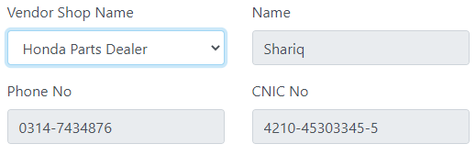

Even for the Item dropdown list. 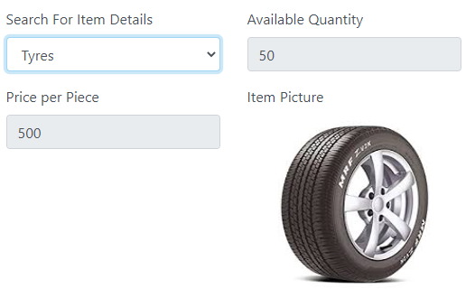

### Guidelines

1. Does the list contain number of values to display the “Scroll” option? And it should be working.
2. Does the alignment of list is associated with control?
3. Do all the dropdown list on this screen are sorted correctly? Alphabetic sorting is the default unless otherwise specified.
4. Do the names in the dropdown list boxes are not abbreviations or cut short?
5. Does it display the appropriate sign (as arrow) over dropdown list?

### Button

### Contributors

Hassan Ahmed Siddiqui, [hassansiddiqi0@gmail.com](mailto:hassansiddiqi0@gmail.com), Usman Institute of Technology

### Purpose

A button is an very common interactive element that is used in every application there is, it enables us to get the expected and interactive feedback for every event performed from the system. Basically, a button is a control that allows a user to directly communicate with the with the application allows you to perform action on it and send the necessary commands or trigger events to achieve a particular goal.

**Example**

Figure 1: Add vendor Button

Figure 2: Add row Button

Figure 3: Generate Invoice and Cancel Buttons

Figure 4: Submit and Generate Button

**Figure 1:** Add vendor button goes to Vendor adding page to create a new vendor.

**Figure 2:** Add row triggers an event to add new row to the table or grid to enter more data

**Figure 3:** Generate invoice bill of the vendor order and save it to the details to database. Cancel button cancels the transaction and navigates back to the order list.

**Figure 4:** Submit and Generate button save the invoice details and navigates back to order list to show the add data.

### Category

Graphical Control

### Test Cases (Steps Based)

1. Does the default button work correctly?

Before clicking the button, filling the data and leaving to some places blank.

After clicking the Generate invoice button it showed the errors went saving the data.

1. Does the button display become “Highlighted” with hovering of mouse cursor on the control?



Before hovering the mouse.

After hovering we can see that they are highlighted.

1. Do the appropriate information displayed as per requirement on hovering of mouse cursor?

On hovering these buttons show information and other buttons also.

1. Do the events occur after clicking on the buttons?

Before clicking the Add row button, to add new row to much more data.

After clicking the button, a new row is added to the grid.

1. Does on the pressing the Command button results in uncorrectable data e.g. closing an action step, there should be a message phrased positively with Yes/No answers where yes results in the completion of the action. Does it show it?

### Guidelines

1. Does the button has Enable or disable property of the control?
2. Do all the command buttons are all of similar sizes and shape, and same font, verify?
3. Does the screen have a specified default button?
4. Do the buttons have alignment with other controls on the window?
5. Do the label on the control editable? They should not be editable.
6. Do the events are successfully executed with single click, Double click and more than double click on the button
7. Does the “Highlighted” button control accept click event with keyboard “Enter” key?

### Radio Button

### Contributors

Hassan Ahmed Siddiqui, [hassansiddiqi0@gmail.com](mailto:hassansiddiqi0@gmail.com), Usman Institute of Technology

### Purpose

Radio buttons may be arranged in a group of two or more and A radio button or option button is a graphical control that allows the user to only select one of the predefined set of mutually exclusive options, it allows more than one or no item to be selected and for the unselected state to be restored.

**Example**



Figure 1: Radio Button

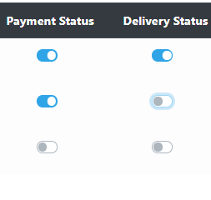

Figure 2: Custom Radio Button

**Figure 1:** The radio button help us to select one and only one predefined option.

**Figure 2:** The custom radio button is the button used to show pre-stored values from the database.

### Category

Graphical control

### Test Cases (Input based)

1. Do the pre-populated checkbox whether they are correct or not from the database?

|  |  |  |  |
| --- | --- | --- | --- |
| Test case Name | Input | Output | Valid /Invalid |
| Pre-populated | Amount Paid |  | Valid |
|  | Amount Paid |  | Invalid |

### Test Cases (Steps Based)

1. Do we cannot select more than one radio buttons?



Only option can be selected at a time, can also been seen in the grid or table.



1. Does on mouse click, space bar and enter key press should change property of radio button from checked to unchecked or vice versa?





After pressing space or clicking enter it is unchecked.

### Guidelines

1. Do an appropriate label for each radio button?
2. Does an appropriate event associated with radio button property change if there are any?
3. Do the disabled radio button not be editable?
4. Does the alignment is proper with other controls in window?

### Image

### Contributors

Hassan Ahmed Siddiqui, [hassansiddiqi0@gmail.com](mailto:hassansiddiqi0@gmail.com), Usman Institute of Technology

### Purpose

Image controls used as icons, informational graphics, and charts will support the Image control type. Controls used as background or watermark images will not support the Image control type.

Images are UI components that allow you to display a picture, such as an icon or logo in your app. Image properties control the appearance and behavior of an image. Use dot notation to refer to a specific object and property.

**Example**

Figure 1: AC Kit Picture

**Figure 1:** This shows what is in the “Ac-kit” that is selected.

### Category

Image control

### Test Cases (Input based)

1. Does the correct is being loaded from the database according to the item selected in the drop-down list.

|  |  |  |  |
| --- | --- | --- | --- |
| Test case Name | Input | Output | Valid /Invalid |
| Image Loading | An item selected such as tyre |  | Valid |
|  | Tube |  | Valid |
|  | Item selected that is not in database |  | Invalid |

### Test Cases (Steps Based)

1. Does it have option of zoom in and zoom out available?

First select an option from the Item Details combo box.

As we can see that there is no option of zoom in and zoom out after loading the image.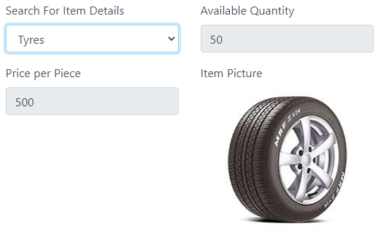

1. Does the image have poor quality and blurring it?

By zooming in using the web zoom feature to enlarge object will help us to see whether the is image has a good or poor quality.



As the image loaded has a good quality.

### Guidelines

1. Does the same image should get displayed either by scan or by import?
2. Does the correct image is being loaded every time the same item selected?

### Table or Grid

### Contributors

Hassan Ahmed Siddiqui, [hassansiddiqi0@gmail.com](mailto:hassansiddiqi0@gmail.com), Usman Institute of Technology

### Purpose

Table controls contain rows and columns of text and optionally also row headers and column headers. It is mostly used to display the stored data and other times used to input the values of in the database.

**Example**

Figure 1: Table or grid of Vendor order

**Figure 1:** Table or grid for the items to be entered with quantity for the order.

### Category

Table control

### Test Cases (Steps Based)

1. Do we can edit the default value?

We can only edit the values of the first as they are enabled.

1. Does the enable textboxes and dropdown list in the grid are editable?

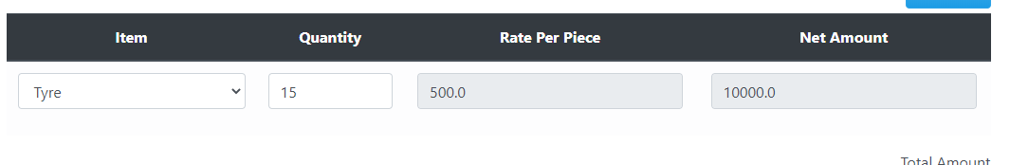

1. Does the data in the disabled textboxes auto-filled correctly?



As the last column of the net amount is auto-filled correctly by multiplying the 2 & 3 columns.

### Guidelines

1. Does the grid have default value?
2. Does the appropriate label for each column in grid control and a heading present in the entire grid control?
3. Do the disabled grid control clickable? It should not be clickable.
4. Do the textboxes and dropdown list in the grid are enabled or disabled?

### References

1. Graphical UI Testing Checklist. [www.raveinfosys.com/Doc/Web%20App%20UI%20Testing%20Checklist%20-%20Web%20App%20UI%20Checks.pdf](http://www.raveinfosys.com/Doc/Web%20App%20UI%20Testing%20Checklist%20-%20Web%20App%20UI%20Checks.pdf).

### REQUIREMENTS:

Here the requirements required for the testing the controls are the data we need that is associated with each textbox, dropdown list, radio button, grid and images and also what are the things requirement of the user are they being full filled or not.

### STRATEGY:

The strategy is to check every possible value for the textboxes with the designed testcases and to check all the functionalities are working properly with any error or bug, also the data that is being received from the database in the correct format to the associated control.

# Interface Testing

### Aesthetic Conditions:

### Contributors

Hassan Ahmed Siddiqui, [hassansiddiqi0@gmail.com](mailto:hassansiddiqi0@gmail.com), Usman Institute of Technology.

**Purpose**The purpose is to understand how the user interacts with product and to improve product based on the results. The purpose of this test is improving the design in a typical aesthetic test. The real user provide the ease to use the interface and also help them to achieve the goal.

**Example**

**Vendor Order Interface**

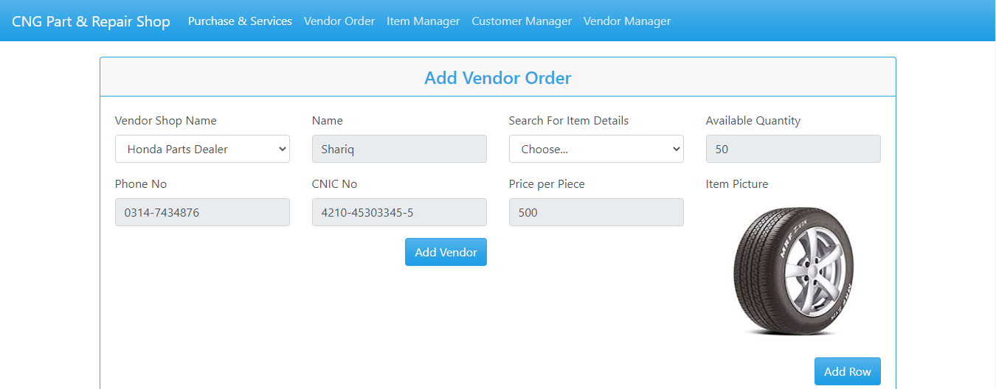 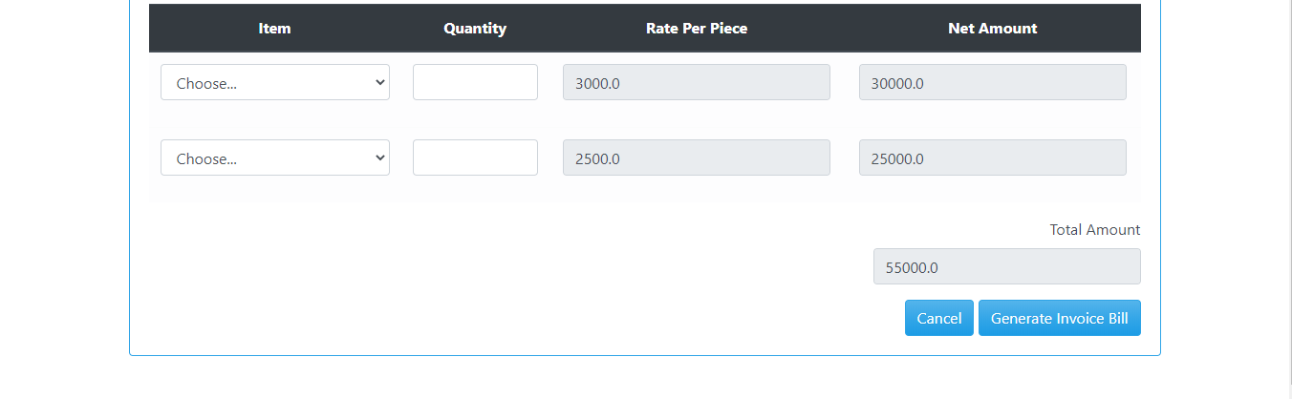

Figure 1 **Vendor Order Interface**

.

**Category:**

Input Base.

**Test case (input Based)**

**User Error**

|  |  |  |  |
| --- | --- | --- | --- |
| Controls | Input | Output | Valid /Invalid |
| Text box | Value exceeds | Textbox filled red display | Invalid |
| Text box | Out of range | prompt | Valid |

**Multiple validation rules**

|  |  |  |  |
| --- | --- | --- | --- |
| Controls | Input | Output | Valid /Invalid |
| Text box | Once the value is stored it will automatically be appeared as suggestion for second time | Textbox filled green display | Valid |

**Numeric validation rules**

|  |  |  |  |
| --- | --- | --- | --- |
| Controls | Input | Output | Valid /Invalid |
| Text box | Matching the data values | Alert out of range | Valid |

**Invalid entry**

|  |  |  |  |
| --- | --- | --- | --- |
| Controls | Input | Output | Valid /Invalid |
| Text box | Special character | Not a number | Valid |
| Text box | Letter | Not a number | Valid |

*.*

**Test cases (step based)**

None

**Guide lines**

* Do check whether expected result is displayed on click?
* Do check the font size of button?
* Do check the font color of button?
* Do check the size of button?
* Check the spelling mistake of the label of the button?
* Does appropriate TEXT associated with the control, checked?
* Does the label of the control have appropriate naming convention?
* Does the general screen background the correct color is selected?
* Do the field prompt the correct color?
* Does the field background the correct color?
* Do read-only mode, are the field prompts the correct color?
* Do read-only mode, are the field backgrounds the correct color?
* Does the screen of all prompts specify in the correct screen font?
* Do the text in all fields specified in the correct screen font?
* Does the field for all prompts aligned perfectly on the screen?
* Does field all the edit boxes aligned perfectly on the screen?
* Do all group boxes align correctly on the screen?
* Does the screen can be resizable?
* Does the screen can be minimized?
* Do all the field prompts spelt correctly?
* Does all character or alpha-numeric fields left justified? This is the default unless otherwise specified.
* Do all numeric fields right justify? This is the default unless otherwise specified.
* Does all the micro help text spell correctly on this screen?
* Does all the error message text spell correctly on this screen?
* Do all user input capture in UPPER case or lower case consistently?
* Does the database require a value (other than null) then this should be defaulted into fields?
* The user must either enter an alternative valid value or leave the default value intact?
* Does it assure that all windows have a consistent look and feel?
* Does it assure that all dialog boxes have a consistent look and feel?

1. **Validation Conditions:**

### Contributors

Hassan Ahmed Siddiqui, [hassansiddiqi0@gmail.com](mailto:hassansiddiqi0@gmail.com), Usman Institute of Technology.

**Purpose**

The purpose is to validate the input data that user provide the desire field is valid or invalid which further in data save and other purposes. It is advisable that the individuals responsible for data validation not be directly involved with data collection.

**Example**

 

Figure 1 **Vendor Order Interface***.*

**Category:**

Input Base.

**Test case (input Based)**

* failure of validation in Name

|  |  |  |  |  |
| --- | --- | --- | --- | --- |
| Controls | Field/control | Input | Output | Valid /Invalid |
| Failure of validation | Name | Mustansar Hussain tarrar Rizvi | Textbox filled red display | Invalid |
| Text box | Name | Mustansar Hussain tarrar | Textbox filled green display | Valid |

* failure of validation of insert of Dot

|  |  |  |  |  |
| --- | --- | --- | --- | --- |
| Controls | Field/control | Input | Output | Valid /Invalid |
| failure of validation | Dot | Hasssan.Shoaib | Textbox filled red display | Invalid |
| Text box |  | Hassan | Textbox filled green display | Valid |

* failure of validation of Numeric

|  |  |  |  |  |
| --- | --- | --- | --- | --- |
| Controls | Field/control | Input | Output | Valid /Invalid |
| failure of validation | Numeric | Unais123 | Textbox filled red display | Invalid |
| Text box |  | Unais Zahid | Textbox filled green display | Valid |

* failure of validation of Special Character

|  |  |  |  |  |
| --- | --- | --- | --- | --- |
| Controls | Field/control | Input | Output | Valid /Invalid |
| Failure of validation | Special Character | Anas@# | Textbox filled red display | Invalid |
| Text box |  | Anas | Textbox filled green display | Valid |

* failure of validation of Arithmetic Input

|  |  |  |  |  |
| --- | --- | --- | --- | --- |
| Controls | Field/control | Input | Output | Valid /Invalid |
| Failure of validation | Arithmetic Character | 123315 | Textbox filled red display | Invalid |
| Text box |  | Unais | Textbox filled green display | Valid |

* failure of validation of Alphanumeric

|  |  |  |  |  |
| --- | --- | --- | --- | --- |
| Controls | Field/control | Input | Output | Valid /Invalid |
| Failure of validation | Alpha-Numeric | ASK-01@ | Textbox filled red display | Invalid |
| Text box |  | ASK-201 | Textbox filled green display | Valid |

**Test cases (step based)**

1. Do the error and validation messages are displayed correctly?

The validation messages are being showed. Also, after correcting the value confirmation feedback is also being shown.

**Guide lines**

* Do check whether textbox is filled red color when error?
* Does the test field input limit to 20 characters?
* Does the Require data is saves
* Does it provide all the text boxes with appropriate tittle to make sure that data is filled correct?
* Does alpha numeric has limit?
* Does name enter when dot is placed between them?
* Does a failure of validation on every field cause a sensible user error message?
* Does the user required to fix entries which have failed validation tests?
* Does any fields have multiple validation rules and if so are all rules being applied?
* Does the user enter an invalid value and clicks on the OK button (i.e. does not TAB off the field) is the invalid entry identified and highlighted correctly with an error message?
* Does validation consistently applied at screen level unless specifically required at field level?
* Do all numeric fields check whether negative numbers can and should be able to be entered?
* Do all numeric fields check the minimum and maximum values and also some mid-range values allowable?
* Do all character/alphanumeric fields check the field to ensure that there is a character limit specified and that this limit is exactly correct for the specified database size?
* Do all mandatory fields require user input?
* If any of the database columns don't allow null values then the corresponding screen fields must be mandatory. (If any field which initially was mandatory has become optional then check whether null values are allowed in this field.)

## **Navigation Condition**

### Contributors

Hassan Ahmed Siddiqui, [hassansiddiqi0@gmail.com](mailto:hassansiddiqi0@gmail.com), Usman Institute of Technology.

**Purpose**  
The purpose of navigation to select the option which is given to the users is enable for that interface at a time when to navigate? And where user will go? The primarily purpose to test the navigation is to provide the valid interfaces where user will go through for looking up their information. The background of testing the navigation for the user to allow operations for the legitimate user to manipulates the data from the given information

**Category:**

Selection Base.

**Example**

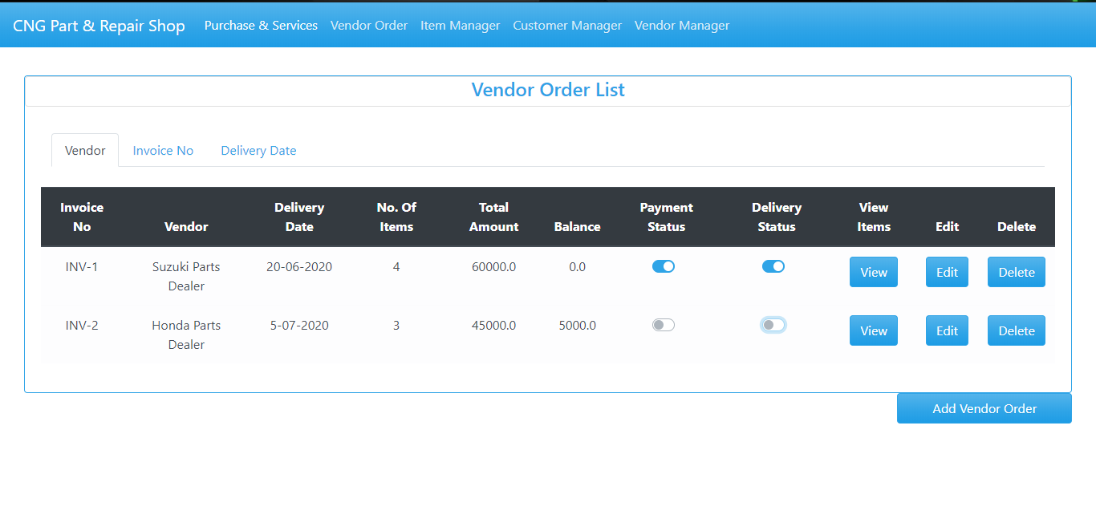

*Figure 1 Vendor order list Interface with sub menu Vendor Name, Invoice No, Delivery Date(selected).*

**Test case (input Based)**

1. Do screen Select from Menu?

|  |  |  |  |
| --- | --- | --- | --- |
| Controls | Input | Output | Valid /Invalid |
| Screen Select from Menu | E:\Black box testing\2.PNG  Select Purchase & Service. | Display Required result | Valid |

1. Do screen Select from Sub Menu?

|  |  |  |  |
| --- | --- | --- | --- |
| Controls | Input | Output | Valid /Invalid |
| Screen Select from Menu | Select Delivery Date from Vendor order List. | Display Required result | Valid |

**Test case (step Based)**

None

**Guidelines**

* Does the selected menu provide the result?
* Does it roll back to the first option?
* Does it provide correct tittle?
* Does menu is easily accusable?
* Do the date is provided?
* Does the screen be accessed correctly from the menu?
* Does the screen be accessed correctly from the toolbar?
* Does the screen be accessed correctly by double clicking on a list control on the previous screen?
* Does screens accessible via buttons on this screen be accessed correctly?
* Do all screens accessible by double clicking on a list control be accessed correctly?
* Does screen model is the user prevented from accessing other functions when this screen is active and is this correct?
* Do a number of instances of this screen be opened at the same time and is this correct?
* Does edit button Validate to edit the data
* Does delete button Validate to delete the data

1. **Usability Conditions:**

### Contributors

Hassan Ahmed Siddiqui, [hassansiddiqi0@gmail.com](mailto:hassansiddiqi0@gmail.com), Usman Institute of Technology.

**Purpose**

The purpose of usability is to provide the user an ease of use is often the biggest factor in the success of any kind of software, web service or mobile app, and navigation tests are great for measuring this in your interface design. They’re simple and to the point—we show users a screen and ask them how they would complete an action. Then we measure how many users manage it, and how quickly

**Example**



*Figure 1 Vendor order list Interface with sub menu Vendor Name, Invoice No, Delivery Date(selected).*

**Category:**

Selection Base.

**Test case (input Based)**

* The dropdowns on this screen sorted correctly? Alphabetic sorting is the default unless otherwise specified?

|  |  |  |  |
| --- | --- | --- | --- |
| Controls | Input | Output | Valid /Invalid |
| Alphabetic sorting in dropdown screen | Select dropdown from | C:\Main Foldf\Downloads\4.PNG   | Invalid |

* Date entry required in the correct format?

|  |  |  |  |
| --- | --- | --- | --- |
| Controls | Input | Output | Valid /Invalid |
| Date entry required in the correct format | E:\Black box testing\Search Date.PNG  Select Delivery Date Vendor order List. | Display Required result | Valid |

* All read-only fields avoided in the TAB sequence?

|  |  |  |  |
| --- | --- | --- | --- |
| Controls | Input | Output | Valid /Invalid |
| Read-only fields avoided in the TAB sequence | Apply Tab sequence to read-only |  | Valid |

* The cursor be placed in read-only fields by clicking in the field with the mouse?

|  |  |  |  |
| --- | --- | --- | --- |
| Controls | Input | Output | Valid /Invalid |
| Cursor be placed in read-only fields by clicking in the field with the mouse? | Select the field | Read Only | Valid |

* Does edit button work correctly?
* Does delete button work correctly

|  |  |  |  |
| --- | --- | --- | --- |
| Controls | Input | Output | Valid /Invalid |
| Edit and Delete data |  | Data is edited and Deleted. | Valid |

* There a default button specified on the screen?

|  |  |  |  |
| --- | --- | --- | --- |
| Controls | Input | Output | Valid /Invalid |
| Default Button | No Default Button | None | Invalid |

* The user Alt+Tab's to another application does this have any impact on the screen upon return to the application

|  |  |  |  |
| --- | --- | --- | --- |
| Controls | Input | Output | Valid /Invalid |
| Alt+Tab's | .  Press Alt+Tab's | No Impact Work Fine. | Valid |

**Test case (step Based)**

* 1. Does the autofill function working it is expected and that there are no UI issues?

All the gray textboxes are auto-filled by some events that are being triggered.

**Guidelines**

* Does the selected dropdown provide the result?
* Does it roll back to the first option?
* Does it provide correct tittle?
* Does it provide correct spell and Grammar?
* Does a text no more than three words in length with all significant first letters capitalized? The use of text is recommended over graphics, it provides a more consistent interface with standard applications?
* Does all the dropdowns on this screen sorted correctly? Alphabetic sorting is the default unless otherwise specified.
* Does all date entry require in the correct format?
* Does all pushbuttons on the screen been given appropriate Shortcut keys?
* Do the Shortcut keys work correctly?
* Do the menu options which apply to your screen have fast keys associated and should they have?
* Does the Tab Order specified on the screen go in sequence from Top Left to bottom right this is the default unless otherwise specified?
* Does all read-only fields avoided in the TAB sequence?
* Does all disabled fields avoided in the TAB sequence?
* Do the cursor be placed in the micro help text box by clicking on the text box with the mouse?
* Does the cursor be placed in read-only fields by clicking in the field with the mouse?
* Do the cursor positioned in the first input field or control when the screen is opened?
* Do there a default button specify on the screen?
* Does the default button work correctly?
* Does an error message occurs does the focus return to the field in error when the user cancels it?
* Do all the fields edit boxes indicate the number of characters they will hold by there length? e.g. a 30-character field should be a lot longer?
* Does edit button work correctly?
* Does delete button work correctly?

## **Data Integrity Conditions**

### Contributors

Hassan Ahmed Siddiqui, [hassansiddiqi0@gmail.com](mailto:hassansiddiqi0@gmail.com), Usman Institute of Technology.

**Purpose**

The purpose of data integrity is that data integrity refers to the maintenance and assurance of the accuracy and consistency of data. It is the characteristic of information to maintain unaltered and intact between transfer, storage, and usage.



*Figure 1 Vendor order list Interface with sub menu Vendor Name, Invoice No, Delivery Date(selected).*

**Test cases (Input based)**

* Do check whether or NOT a blank value or default value can be retrieved from the database?

|  |  |  |  |
| --- | --- | --- | --- |
| Controls | Input | Output | Valid /Invalid |
| Blank Space Check | E:\Black box testing\Search Customer Name.PNG | E:\Black box testing\Search Customer Name.PNG | Valid |

* Do verify that you can create, modify, and delete any data in tables?

|  |  |  |  |
| --- | --- | --- | --- |
| Controls | Input | Output | Valid /Invalid |
| Verify Edit and Delete data |  | Data is edited and Deleted. | Valid |

**Test cases (step based)**

None

**Guidelines**

* Does the selected data provide the correct result?
* Does the user data is integrated?
* Does it allow the user to enter the blank data?
* Does the retrieve data same as save data?
* Does the data can retrieve correct after shutdown?
* Does it save as Upper Letter of name?
* Does the Save and Next Command button proceed the further data into database?
* Do all field provide the data and data like N.I.C is more secure?
* Do check whether or NOT a blank value or default value can be retrieved from the database?
* Does it validate each value if it is successfully saved to the database?
* Do it ensuring the data compatibility against old hardware or old versions of operating systems?
* Does it verifying the data in data tables can be modified and deleted?
* Does running data tests for all data files, including clip art, tutorials, and templates?
* Does it verify that you can create, modify, and delete any data in tables?
* Does it verify that sets of radio buttons represent fixed sets of values?
* Does it verify that a blank value can be retrieved from the database?
* Does it verify that, when a particular set of data is saved to the database, each value gets saved fully, and the truncation of strings and rounding of numeric values do not occur?
* Does it verify that the default values are saved in the database, if the user input is not specified?
* Does it verify compatibility with old data, old hardware, versions of operating systems, and interfaces with other software?
* Does it provide data integrity and Data should be stored in single or multiple tables based on the design?
* Does Data should be rolled back in case of failed transactions?
* Does Input field leading and trailing spaces should be truncated before committing data to the database?
* Does Null values should not be allowed for the Primary key column?

## **Feedback**

### Contributors

Hassan Ahmed Siddiqui, [hassansiddiqi0@gmail.com](mailto:hassansiddiqi0@gmail.com), Usman Institute of Technology.

**Purpose**

The purpose is to provide a person must have to fill in a column a required field entry, system should accept valid entry, when you have entered whole information of customer you will choose the brand, if you have committed a fault you must edit the entry or delete the entry and help others to provide more useful service.



Figure 1 :Feedback messege through command button

**Category:**

Input Base.

**Test case (input Based)**

Ensure that an error message is displayed on submitting the form by leaving the mandatory fields empty. Expected error messages for the above example is:

"Your Vendor **Shop** name field is required."

"Search for item Details field is required."

**Vendor Shop Name field:**

Ensure that the system accepts valid name. If the field is customized, then test accordingly.

Ensure that the system rejects the invalid (Select: *Choose..*).

**Search for item Details**

Ensure that the system accepts the valid **Search for item.** If the field is customized, then test accordingly. Ensure that the system rejects the invalid (Select: *Choose. *).



**Edit button:**

Ensure that the spelling and position of the button is correct.

Ensure that the button is clickable.

Ensure that on submitting a valid form, the value get saved and administrator receives the same data

**Delete button:**

Ensure that the spelling and position of the button is correct.

Ensure that the button is clickable.

Ensure that on delete an entry should be updated in the system

* 1. Does a person fill anything its mandatory fields should be entered?

|  |  |  |  |
| --- | --- | --- | --- |
| Controls | Input | Output | Valid /Invalid |
| Fill mandatory fields |  | Textboxes filled red if blank fields are left | Valid |

**Test case (step Based)**

* Dos the site logo visible and clickable?

By clicking the logo or name it navigates to the starting page of website.

**Guide lines**

* Does a person fill anything its mandatory fields should be entered?
* Does it should be validated that a system accepts valid entry?
* Does the Data should be rolled back in case of failed transactions?
* Does it pop a message if user input invalid data multiple times?
* Does it should must provide option for edit data if fault occurs?
* Does it ensure that the spelling and position of the button is correct?
* Does it ensure that the button is clickable?
* Does it ensure that on submitting a valid form, the value get saved and administrator receives the same data?
* Does it ensure that the spelling and position of the button is correct?
* Does it ensure that the button is clickable?
* Does it ensure that on delete an entry should be updated in the system?

## **Modes**

### Contributors

Hassan Ahmed Siddiqui, [hassansiddiqi0@gmail.com](mailto:hassansiddiqi0@gmail.com), Usman Institute of Technology.

**Purpose**

The purpose of modes condition is to detect and then verify any data values at the required system. This allow user to editable read only modes and check that the read-only mode is valid.

Figure 1: Shows read only mode

**Category:**

Input Base.

**Test cases (input based)**

None

**Test cases (step based)**

* The screen and field colors adjusted correctly for read-only mode

|  |  |  |  |
| --- | --- | --- | --- |
| Controls | Input | Output | Valid /Invalid |
| The screen and field colors adjusted correctly for read-only mode | Color are read only | None | Valid |

* Check for error messages, for example, « invalid entry, Please, enter valid data» in case of incorrect entry operation

|  |  |  |  |
| --- | --- | --- | --- |
| Controls | Input | Output | Valid /Invalid |
| Error Message | Invalid Input | Textbox filled red display | Valid |

* Read-only mode be provided for this screen

|  |  |  |  |
| --- | --- | --- | --- |
| Controls | Input | Output | Valid /Invalid |
| Read-Only for screen |  |  | Valid |

* Check the right template sizes are shown in a good manner?

|  |  |  |  |
| --- | --- | --- | --- |
| Controls | Input | Output | Valid /Invalid |
| Checking Template Size | Date | E:\Black box testing\Search Date.PNG | Valid |

**Guide line**

* Does it check the correctness of the app?
* Does it make sure the required fields are not displayed on the screen as optional?
* Does it ensure the software goes into the background in the case of a deleting record?
* Does it ensure that the software cannot shuts if the networks make disconnected?
* Does it make sure the application automatic startup is correct?
* Does it check for error messages, for example, « invalid entry lease, enter valid data» in case of incorrect entry operation?
* Does the screen and field colors adjust correctly for read-only mode?
* Do a read-only mode be provided for this screen?
* Does all fields and controls disable in read-only mode?
* Does the screen be accessed from the previous screen/menu/toolbar in read-only mode?
* Does all screens available from this screen be accessed in read-only mode?
* Does it check that no validation is performed in read-only mode?
* Do it confirm that software Logo ought not to be blurred and title of the software ought not to be incorrectly spelled?
* Does check the right template sizes are shown in a good manner?
* Does it check for error messages, for example, « invalid entry, Please, enter valid data» in case of incorrect entry operation

**2. Is the user required to fix entries which have failed validation tests?**

NO

## **8.** **General Condition**

### Contributors

Hassan Ahmed Siddiqui, [hassansiddiqi0@gmail.com](mailto:hassansiddiqi0@gmail.com), Usman Institute of Technology.

**Purpose**

A general condition agreement is a set of regulations which users must agree to follow in order to use a service of mobiles and webs. It is basically to inform users:

* The guidelines of using your website or mobile app, what happens if users are abusing your website or mobile app. that you are the owner of such content
* The content you own is protected by international copyright laws. that abusive accounts will be terminated and banned from using the service.
* The owner can’t be held responsible for any errors in the content presented, or for the information provided being accurate, complete, or suitable for any purpose

**Test cases (input based)**

* + Does date entry require in the correct format?

|  |  |  |  |
| --- | --- | --- | --- |
| Controls | Input | Output | Valid /Invalid |
| Date entry required in the correct format | Select Delivery Date from Vendor List. | E:\Black box testing\Search Date.PNGDisplay Required result | Valid |

* + Do all read-only fields avoided in the TAB sequence?

|  |  |  |  |
| --- | --- | --- | --- |
| Controls | Input | Output | Valid /Invalid |
| Read-only fields avoided in the TAB sequence | Apply Tab sequence to read-only | E:\Black box testing\Search Date.PNG | Valid |

* + Do the cursor be placed in read-only fields by clicking in the field with the mouse?

|  |  |  |  |
| --- | --- | --- | --- |
| Controls | Input | Output | Valid /Invalid |
| Cursor be placed in read-only fields by clicking in the field with the mouse? | Select the field | Read Only | Valid |

* + Does edit button work correctly?
  + Does delete button work correctly?

|  |  |  |  |
| --- | --- | --- | --- |
| Controls | Input | Output | Valid /Invalid |
| Edit and Delete data |  | Data is edited and Deleted. | Valid |

* + Do there a default button specify on the screen?

|  |  |  |  |
| --- | --- | --- | --- |
| Controls | Input | Output | Valid /Invalid |
| Default Button | No Default Button | None | Invalid |

* + Do all fonts to be the same?

|  |  |  |  |
| --- | --- | --- | --- |
| Controls | Input | Output | Valid /Invalid |
| Font Size |  | None | Valid |

* + Do read-only mode be provided for this screen

|  |  |  |  |
| --- | --- | --- | --- |
| Controls | Input | Output | Valid /Invalid |
| Read-Only for screen |  |  | Valid |

**Test cases (step based)**

* Do the elements in the dropdown are not overlapping? They should not be.

As the elements are not overlapped.

**Guidelines**

* Does it assure the existence of the "Help" menu?
* Does it assure that the proper commands and options are in each menu?
* Does it assure that all buttons on all tool bars have a corresponding key commands?
* Does it assure that each menu command has an alternative (hot-key) key sequence which will invoke it where appropriate?
* Do the drop-down list boxes, ensure that the names are not abbreviations / cut short?
* Do the drop-down list boxes, assure that the list and each entry in the list can be accessed via appropriate key / hot key combinations?
* Does the retrieve on load of tabbed window fails window should not open?
* Does it ensure that duplicate hot keys do not exist on each screen?
* Does it ensure the proper usage of the escape key (which is to undo any changes that have been made) and generates a caution message "Changes will be lost - Continue yes/no"
* Does it assure that the cancel button functions the same as the escape key?
* Does it assure that the Cancel button operates as a Close button when changes have be made that cannot be undone?
* Does it assure that only command buttons which are used by a particular window, or in a particular dialog box, are present - I.e. make sure they don't work on the screen behind the current screen?
* Does it assure a command button is used sometimes and not at other times, assure that it is grayed out when it should not be used?
* Does it assure that OK and Cancel buttons are grouped separately from other command buttons?
* Does it assure that command button names are not abbreviations?
* Does it assure that all field labels/names are not technical labels, but rather are names meaningful to system users?
* Does it assure that command buttons are all of similar size and shape, and same font & font size?
* Does it assure that each command button can be accessed via a hot key combination?
* Does it assure that command buttons in the same window/dialog box do not have duplicate hot keys?
* Does it assure that each window/dialog box has a clearly marked default value (command button, or other object) which is invoked when the Enter key is pressed - and NOT the Cancel or Close button?
* Does it assure that focus is set to an object/button which makes sense according to the function of the window/dialog box?
* Does it assure that all option buttons (and radio buttons) names are not abbreviations?
* Does it assure that option button names are not technical labels, but rather are names meaningful to system users?
* Do hot keys are used to access option buttons, assure that duplicate hot keys do not exist in the same window/dialog box?
* Does it assure that option box names are not abbreviations?
* Does it assure that option boxes, option buttons, and command buttons are logically grouped together in clearly demarcated areas "Group Box"?
* Does it assure that the Tab key sequence which traverses the screens does so in a logical way?
* Does it assure consistency of mouse actions across windows?
* Does it assure that the color red is not used to highlight active objects (many individuals are red-green color blind).
* Does it assure that the user will have control of the desktop with respect to general color and highlighting (the application should not dictate the desktop background characteristics).
* Does it assure that the screen/window does not have a cluttered appearance?
* Does Ctrl + F6 opens next tab within tabbed window?
* Does Shift + Ctrl + F6 opens previous tab within tabbed window?
* Does Tabbing will open next tab within tabbed window if on last field of current tab?
* Does Tabbing will go onto the 'Continue' button if on last field of last tab within tabbed window?
* Does Tabbing will go onto the next editable field in the window?
* Does Banner style & size & display exact same as existing windows?
* Do if we press 8 or less options in a list box, display all options on open of list box - should be no need to scroll?
* Does errors on continue will cause user to be returned to the tab and the focus should be on the field causing the error. (I.e. the tab is opened, highlighting the field with the error on it)
* Do pressing continue while on the first tab of a tabbed window (assuming all fields filled correctly) will not open all the tabs?
* Does on open of tab focus will be on first editable field?
* Does all fonts to be the same?
* Does press Alt+F4 will close the tabbed window and return you to main screen or previous screen (as appropriate), generating "changes will be lost" message if necessary?
* Does micro help text for every enabled field & button?
* Does it ensure all fields are disabled in read-only mode?
* Does progress messages on load of tabbed screens?
* Does the return operates continue?
* Does the retrieve on load of tabbed window fails window should not open?
* Does the Font styles - Font size, color, and family are same in the interface?
* Do the images are not breaking and don’t have any watermarks?
* Do the label text is clearly readable?
* Do the elements are not breaking or distorted on different browsers and screen resolutions?
* Does there any spelling mistakes in the field labels and web page headings?
* Do the disabled fields are not accepting any input?
* Do the links are visible and distinguishable from the other text such as the navbar links?
* Does there any unnecessary blank spaces between the elements on the web page?
* Do the horizontal and vertical scrollbars are appearing wherever necessary?
* Does the web elements are not overlapping anywhere on the web page?
* Does there no broken links on the web page? There should not be any.

Make changes in software only by us

Don’t spoil the rights

## **REFERENCES**

[1]Atul.“GraphicalUITestingChecklist.”Stickyminds, [www.stickyminds.com/sites/default/files/article/file/2014/Graphical%20UI%20Testing%20Checklist.pdf](http://www.stickyminds.com/sites/default/files/article/file/2014/Graphical%20UI%20Testing%20Checklist.pdf).

[2] Bhadauria, Tarun Kumar. “No Automated Testing: Manual Testing Checklist.” *Selenium Software Testing*, www.seleniumtests.com/2014/05/manual-testing-checklist.html.

[3] Borysowich, Craig. “Radio Buttons Checklist.” *Tech*, it.toolbox.com/blogs/craigborysowich/radio-buttons-checklist-102306.

[4] Harris, Andy, and About the Book Author Andy Harris taught himself programming because it was fun. Today he teachers computer science. “How to Create a Radio Button in an HTML5 Form.” *Dummies*, www.dummies.com/web-design-development/site-development/how-to-create-a-radio-button-in-an-html5-form/.

[5]

[“GUI Testing Tutorial: User Interface (UI) TestCases with Examples.”](http://\“GUI Testing Tutorial: User Interface (UI) TestCases with Examples.\” Guru99, www.guru99.com/gui-testing.html.) *[Guru99](http://\“GUI Testing Tutorial: User Interface (UI) TestCases with Examples.\” Guru99, www.guru99.com/gui-testing.html.)*[, www.guru99.com/gui-testing.html.](http://\“GUI Testing Tutorial: User Interface (UI) TestCases with Examples.\” Guru99, www.guru99.com/gui-testing.html.)

[6]

[Amrutha, et al. “180+ Sample Test Cases for Testing Web and Desktop Applications - Comprehensive Software Testing Checklist.”](http:// Amrutha, et al. \“180+ Sample Test Cases for Testing Web and Desktop Applications - Comprehensive Software Testing Checklist.\” Software Testing Help, 30 June 2020, www.softwaretestinghelp.com/sample-test-cases-testing-web-desktop-applications/.[7] \“Data Integrity Testing.\” Tutorialspoint, www.tutorialspoint.com/software_testing_dictionary/data_and_database_integrity_testing.htm.) *[Software Testing Help](http:// Amrutha, et al. \“180+ Sample Test Cases for Testing Web and Desktop Applications - Comprehensive Software Testing Checklist.\” Software Testing Help, 30 June 2020, www.softwaretestinghelp.com/sample-test-cases-testing-web-desktop-applications/.[7] \“Data Integrity Testing.\” Tutorialspoint, www.tutorialspoint.com/software_testing_dictionary/data_and_database_integrity_testing.htm.)*[, 30 June 2020, www.softwaretestinghelp.com/sample-test-cases-testing-web-desktop-applications/.](http:// Amrutha, et al. \“180+ Sample Test Cases for Testing Web and Desktop Applications - Comprehensive Software Testing Checklist.\” Software Testing Help, 30 June 2020, www.softwaretestinghelp.com/sample-test-cases-testing-web-desktop-applications/.[7] \“Data Integrity Testing.\” Tutorialspoint, www.tutorialspoint.com/software_testing_dictionary/data_and_database_integrity_testing.htm.)

[[7] “Data Integrity Testing.”](http:// Amrutha, et al. \“180+ Sample Test Cases for Testing Web and Desktop Applications - Comprehensive Software Testing Checklist.\” Software Testing Help, 30 June 2020, www.softwaretestinghelp.com/sample-test-cases-testing-web-desktop-applications/.[7] \“Data Integrity Testing.\” Tutorialspoint, www.tutorialspoint.com/software_testing_dictionary/data_and_database_integrity_testing.htm.) *[Tutorialspoint](http:// Amrutha, et al. \“180+ Sample Test Cases for Testing Web and Desktop Applications - Comprehensive Software Testing Checklist.\” Software Testing Help, 30 June 2020, www.softwaretestinghelp.com/sample-test-cases-testing-web-desktop-applications/.[7] \“Data Integrity Testing.\” Tutorialspoint, www.tutorialspoint.com/software_testing_dictionary/data_and_database_integrity_testing.htm.)*[, www.tutorialspoint.com/software_testing_dictionary/data_and_database_integrity_testing.htm.](http:// Amrutha, et al. \“180+ Sample Test Cases for Testing Web and Desktop Applications - Comprehensive Software Testing Checklist.\” Software Testing Help, 30 June 2020, www.softwaretestinghelp.com/sample-test-cases-testing-web-desktop-applications/.[7] \“Data Integrity Testing.\” Tutorialspoint, www.tutorialspoint.com/software_testing_dictionary/data_and_database_integrity_testing.htm.)

[8] “Database Testing Checklist:” *ProfessionalQA.com*, www.professionalqa.com/database-testing-checklist.

[9] freeCodeCamp.org. “User Interface Test Automation.” *FreeCodeCamp.org*, FreeCodeCamp.org, 20 Oct. 2017, www.freecodecamp.org/news/user-interface-test-automation-3da36b132077/.

[10]

[Kaur, Hamraj, et al. “Mobile App Testing Tutorials (A Complete Guide with 30+ Tutorials).”](http:// Kaur, Hamraj, et al. \“Mobile App Testing Tutorials (A Complete Guide with 30+ Tutorials).\” Software Testing Help, 30 June 2020, www.softwaretestinghelp.com/beginners-guide-to-mobile-application-testing/.https://www.testbytes.net/blog/test-scenario-GUI-interface/) *[Software Testing Help](http:// Kaur, Hamraj, et al. \“Mobile App Testing Tutorials (A Complete Guide with 30+ Tutorials).\” Software Testing Help, 30 June 2020, www.softwaretestinghelp.com/beginners-guide-to-mobile-application-testing/.https://www.testbytes.net/blog/test-scenario-GUI-interface/)*[, 30 June 2020, www.softwaretestinghelp.com/beginners-guide-to-mobile-application-testing/.](http:// Kaur, Hamraj, et al. \“Mobile App Testing Tutorials (A Complete Guide with 30+ Tutorials).\” Software Testing Help, 30 June 2020, www.softwaretestinghelp.com/beginners-guide-to-mobile-application-testing/.https://www.testbytes.net/blog/test-scenario-GUI-interface/)

[11]“Software Testing and QA Consulting Company.” *Testbytes*, 26 June 2019, www.testbytes.net/.

[12]“Trustpilot Legal - Terms & Conditions.” *Trustpilot*, legal.trustpilot.com/for-reviewers/end-user-terms-and-conditions.

[13] qed42. “UI Testing Checklist.” *QED42*, [www.qed42.com/blog/ui-testing-checklist](http://www.qed42.com/blog/ui-testing-checklist)

### REQUIREMENTS:

The requirements are the interfaces which needs to be tested and data associated with each control that are in the interface that is being tested. The requirement of the user is required as the develop interface is full filling the needs of the user or not.

## **STRATEGY:**

Strategy is to test every part of the interface that is working as a single entity in the testing. The fonts, images, icons, and every feature that is added to the interface is to be tested according to the testcases developed. This will surely make our interface error and bugs free.

# Develop a Driver (for transactional interface)

1. We need to check what data from the database is to be used in this interface and excluding the other data that irrelevant for this transactional interface.
2. Develop the interface whether it is a transactional or single in a way that their required data is being provided to them without depending on the other interfaces.
3. The features or functionalities provide in each of the interfaces is to be present in that driver and should be working properly and efficiently.
4. The interface layout should not be hindered by it opening in a different application or in a different web.
5. The color theme, textboxes, dropdown list, checkboxes and other control should be aligned according to the requirements.
6. As for the transactional interfaces there may be some single interface functionalities attached to it, to perform its features correctly and fully.
7. The single interface like Add Vendor its functionalities should be developed as a CRUD module and the Transactional interface like Vendor Order’s functionalities are to be developed by attached the single interfaces required for it.
8. Develop these functionalities as an API to work as a service and run these on the interfaces check whether they are working properly or not.
9. Similar doing the process to develop another interface.

**PROPOSED INTERFACE:**

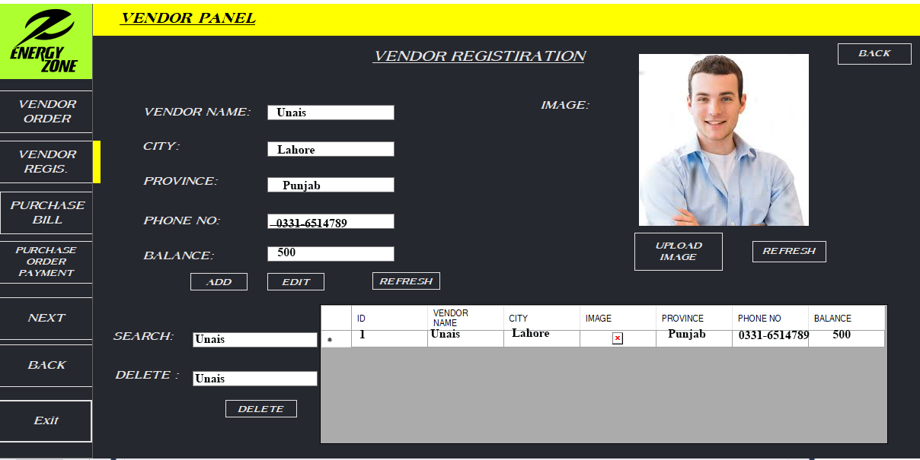

FIGURE :1 GUI PROPESED INTERFACE OF VENDOR REGISTRATION

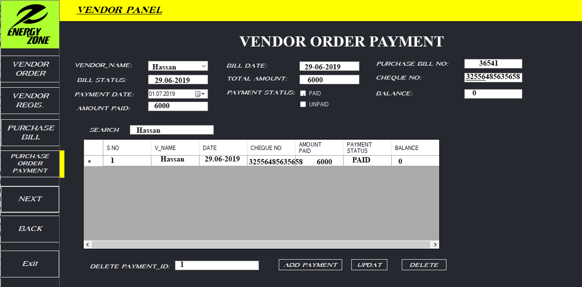

FIGURE :2 GUI PROPESED INTERFACE OF VENDOR ORDER

# Application Testing

### Contributors

SHOAIB AHMED, 17b-033-se@students.uit.edu, Usman Institute of Technology.

## **Screen Containers**

In this application do we have 2 screen containers?

### Does application have navigation container?

This container used for navigation of different pages in our application.

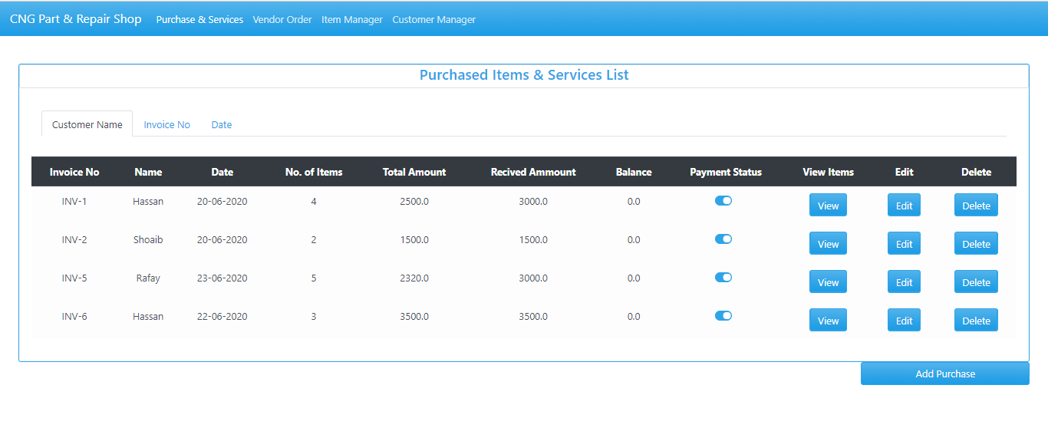

### Does application have view container?

This container is used for to view the detail of the customer, item, vendors etc.

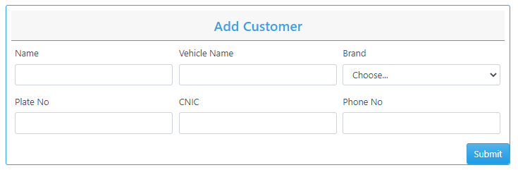

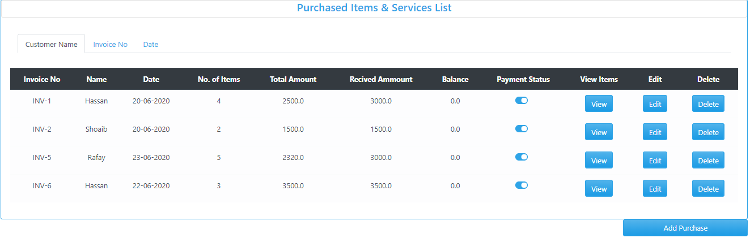

## **Element selection**

In our application we have 6 types of element selection

### Does application have text box?

Figure 1: Textbox for alpha value

Figure 2: Read-Only Textbox for alphanumeric value

Figure 3: Read-Only Textbox for numeric value

**s**

Figure 4: Textbox for numeric value

### Command button

Figure 1: Add vendor Button

Figure 2: Add row Button

Figure 3: Generate Invoice and Cancel Buttons

Figure 4: Submit and Generate Button

### Does application have radio button?



### Does application have dropdown list?



### Does application have table or Grid?

### Does application have Image inserting?

Figure 5: image of item

1. Does application have date picker?

Figure 5: Textbox for date value

## **Element layout**

* **Does application use one control in multiple time in multiple interfaces**?

We use same control in our two interface which is use multiple time in our application as element layout



Textbox for numeric value

Textbox for date value

## **Color theme**

* **Does application use Blue color theme throughout the whole process**?

We use blue color theme in our application entirely.

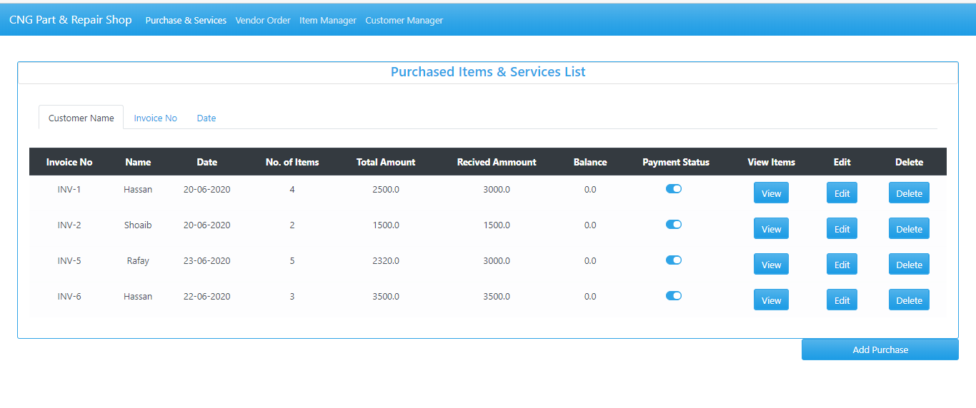

## **Alignment of text**

* **Does application use left alignment of text throughout the whole process**?

We use left alignment in all our typing and selective controls.

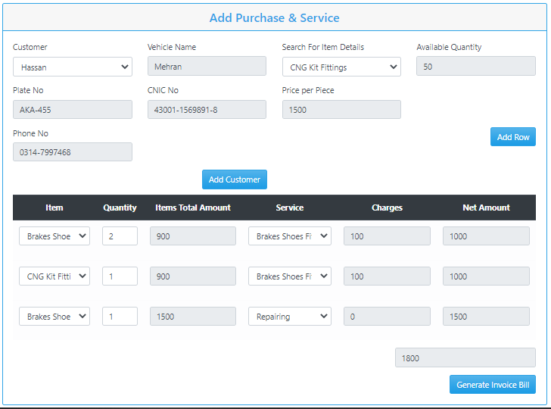

## **Element placement Style**

* **Does application use left element placement style of text throughout the whole process**?

Through our application element placement style is left align in all interfaces.



## **Navigation Style**

* **Does application use navigation by navbars**?

Throughout our application navigation perform with navigation bars

### App navigation

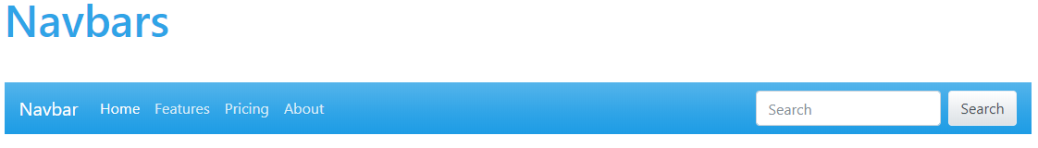

## **Feedback Style**

* **Does application have warning feedback style**?

Our application feedback style is warning message.

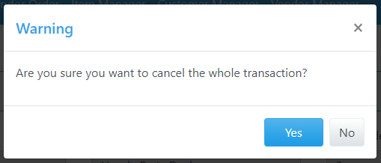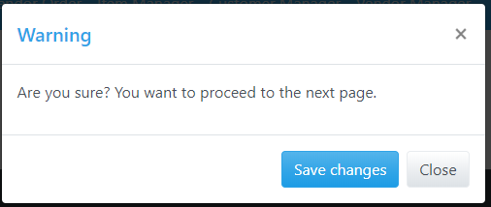

## **Support Style**

* **Does application have warning support style**?

Our application support style is warning message.

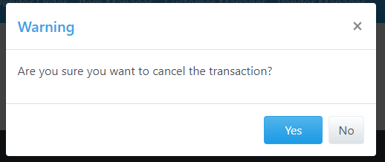

## **Mouse cursor style**

In our application we use three type of mouse cursor style

* **Does application have normal select cursor?**

It is use in drop down and radio buttons.



* **Does application have Text selects cursor?**

It is use in all text boxes.



* **Does application have link selects cursor?**

It is use in all command button.



## **Interface Style**

* **Does application have form based interface style?**

We use form-based interface style throughout our application.









## **REQIREMENTS**

Here are the following requirements:

* Color them must be in blue color.
* Interface style must be form based.
* Elements must be left align.
* Feedback style and support style must be a warning.

**STRATEGY:**

#### **Navigation of Purchase Interface**

The application starts with the navigation on to the first page i.e. Purchase List

Now here are 2 possibilities, occur whether it selects the options from the navbar to navigate to a different web page or choose from the other four events buttons on the table first let’s see the table features;

1. **By clicking the view button**

It will show the details of the items purchased by the customer and then return to Purchase List.

1. **By clicking the edit button**

It will navigate to purchase edit page from that particular row where edit was selected to edit the details of that purchase.

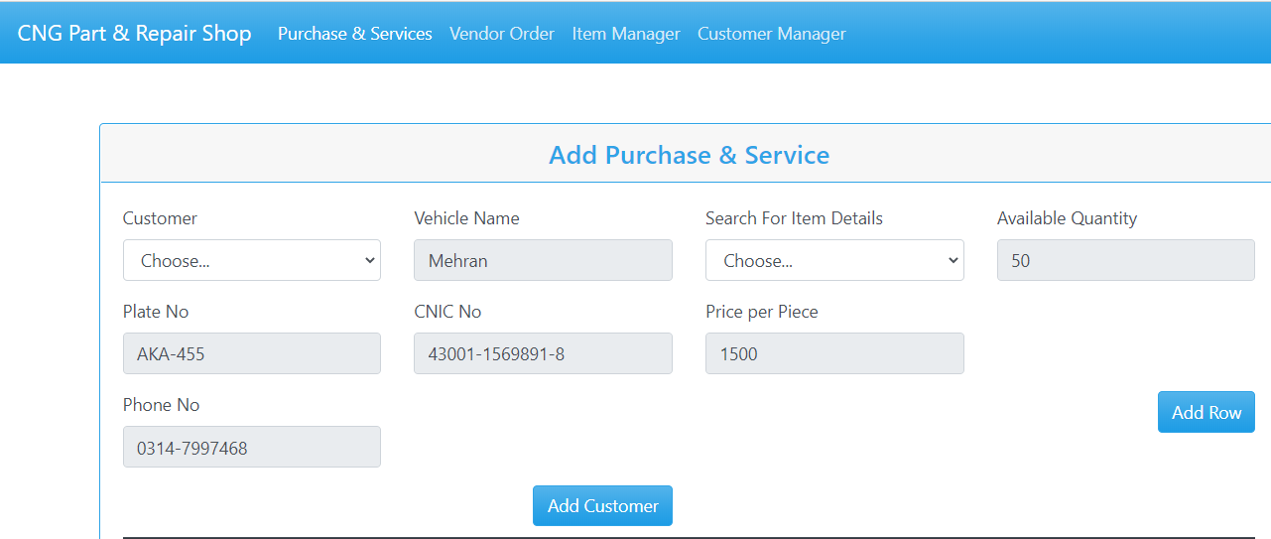



* + 1. **By clicking the add customer button:**

It will navigate to add customer page to filled the detail of the customer.



* **By clicking the submit button**

It will navigate to customer list page to show that the customer detail .

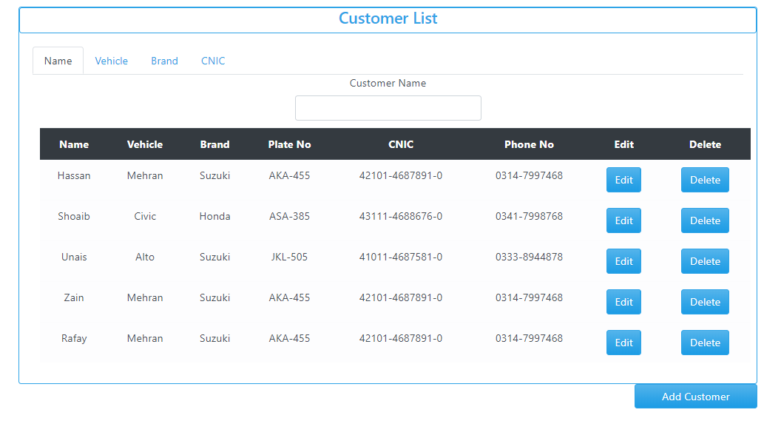

* + 1. **By clicking the Generate Invoice Bill button:**

It will navigate to invoice bill page to show that the customer detail and its order amount of their purchase.

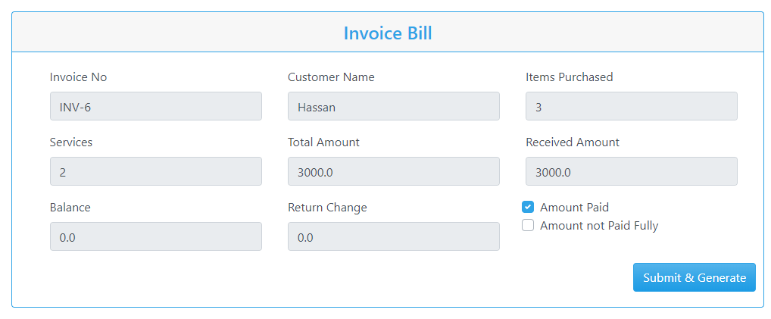

**By clicking the Submit & Generate button**

It will navigate to purchase page to show that the customer detail and its order amount of purchase.

1. **By clicking the delete button**

It will trigger the event of delete the entire row from the purchase list and navigate to purchase list to show the new list.

#### **Navigation of Vendor Order Interface**

The application then navigation on to the second page i.e. Vendor order list

Now here are 2 possibilities, occur whether it selects the options from the navbar to navigate to a different web page or choose from the other four events buttons on the table first let’s see the table features;

1. **By clicking the view button**

It will show the details of the items purchased by the vendor and then return to vendor List order.

1. **By clicking the edit button**

It will navigate to vendor edit page from that particular row where edit was selected to edit the details of that purchase.

* **By clicking the add vendor button:**

It will navigate to vendor order list page to show that vendor is added to the list.

* **By clicking the Generate Invoice Bill button:**

It will navigate to vendor invoice bill page to show that the vendor detail and its order amount.

* **By clicking the Submit & Generate button**

It will navigate to vendor order list page to show that the vendor detail and its order amount.

* **By clicking the cancel button**

It will navigate to vendor order list page to show that the vendor detail and its order amount.

1. **By clicking the delete button**

It will trigger the event of delete the entire row from the purchase list and navigate to purchase list to show the new list.

